Global Commercial

Document title: | COM002 Policy for Prices and Discounts
Document Filename: | COM002 Policy for Prices and Discounts
Document number:
Author: | Laurent Dubois
Version: | 1.0
Saved: | Tuesday, 18 March 2014 14:51

Distribution List:
Area | Full Name

Review and Approval Table
Approval Stage | Name | Dated | Approval | Need by Date
Note: The attached document has been provided to you for approval. So that we can stay on schedule, please review the document by the Need By Date, and enter the appropriate approval (listed below):
- Y = Yes, I approve.
- N = No, I do not approve.
- WC = I approve with the conditions shown in my Comments.

Please attach your comments to this document. You may also annotate the document. After you have reviewed and approved/rejected the document, return it to the person who requested the approval.

Change History
Version number | Author | Date | Summary of changes
1.0 | Laurent Dubois | 23.07.2013 | First version

Table of Contents

Global Commercial 1
Global Commercial Policy: Prices and Discounts 4
1. Purpose 4
2. Definitions 4
2.1 Prices 4
2.2 Currencies 4
2.3 Discounts and Rebates 5
2.4 Agreements - contracts 5
2.5 Promotions 6
2.6 Means of order 6
2.7 Multiple Order Quantity (MOQ) 7
2.8 Channels of distribution 7
3. Principles 8
4. Prices 9
4.1 List Prices 9
4.2 Linked price lists 10
5. Discounts 11
5.1 Discount Policy 11
5.2 Discounts on products 11
5.2.1 Types of discounts on products: 11
5.2.2 Minimum order quantities 12
5.2.3 Product Hierarchy 12
5.3 Discount on Customers 13
5.4 Discount Models 14
5.4.1 Discount priorities 14
5.4.2 Level (1): base discount, brand, brand/activity 16
5.4.3 Level (2): product group/format, additional discount 17
5.4.4 Level (3): head code / SKU / product group, additional discount 18
5.4.5 Level (4): head code / SKU / product group, substitute discount 19
5.4.6 Level (5): blanket agreement 19
5.4.7 Level (6): footer discount 19
6. Mainland Europe 20
6.1 Overview 20
6.2 European Commercial Policy (ECP) - Trade Discount 20
6.3 ColArt Premium Programme (CPP) - Loyalty Discount 21
6.4 Backend (rebate) 22

7. USA/Canada 23
7.1 Overview 23
7.2 Trade discount 23
7.3 Additional trade Discount 24
7.4 Large Order Discount 24
7.5 Backend – Partnership for Growth 24
8. Other Territories 25
9. Controlling Processes 25
10. Related Areas and Processes 26
11. Issue management process 26
Appendix 27

Global Commercial Policy: Prices and Discounts

Purpose
The purpose of this document is to define the rules to manage Prices, Discounts and Terms of Sale on line with ColArt business objectives.

Definitions

Prices

- A Recommended Retail Price (RRP) is a suggested price to end-users
  - It is used in some countries for calculating the dealers’ net price (ex: UK, US)
  - It is used in some other countries for information (ex: Holland, Spain)
  - It is not allowed in all countries to have an official RRP (ex: France, Germany)
- A Dealer List Price (DLP) is an official printed price to dealers for mainland Europe and other countries
  - The DLP is approximately the RRP incl. 20% VAT divided by 2
- A Contract Price is a net price agreed to a customer for a limited period of time (generally 1 year)
- A Street Price is the actual end-user price generally observed on the market

Currencies

- Products can be invoiced in different currencies depending on the country and where the goods are shipped from
- In Europe, some markets are not using the Euro (ex: SEK, CHF). The List Price quoted in other currencies shall reflect the List Price in Euros after potentially adding a mark-up to cover specific local costs (ex: freight and duties in Switzerland)
- The exchange rate will be the rate defined in the budget by the Group. However if there is a significant variance within a year, the exchange rate might be adjusted and the price list updated (ex: triangular sales from China, USD/CNY)

Mainland Europe | EUR
Switzerland | CHF
Sweden | SEK
UK | GBP
USA | USD
China (local) TBC | CNY
Export (ex Europe) | EUR/GBP/USD
Export (ex CN) | USD

Discounts and Rebates

- A discount is rewarding the customer on specific criteria. It will be applied directly on the invoice

- A rebate (back-end) is a refund based on the net amount of purchase of the customer. It is paid to the customer in the beginning of the year following the sales (credit note or payment)

- A Cash discount (or settlement discount) is rewarding an early payment and is deducted by the customer off the net total of the invoice.

- Discount on invoice vs back-end:
  - The discount on invoice can be partly shifted to a backend
  - It can be the case for a chain which requires a backend to finance its purchasing organization. However it is the choice of the customer (often within his Terms of Purchase) and the total level of discount will remain the same and consistent with the commercial policy.
  - It must be clearly specified by written agreement signed-off by both parties

Agreements - contracts

- Terms & Conditions of Sale (TCS)
  - TCS precise the general terms of sales: term of payment, incoterm, jurisdiction …
  - TCS are printed on the back of the invoice (page 2) as well as in the locally printed pricelists
  - TCS will be consistent within a Region with potentially minor adaptations due to local legislation

- Specific Conditions of Sale (SCS)
  - must be specified in a written document approved by both ColArt and the Customer
  - must be signed-off by the CCO before being confirmed to the Customer if they differ from the Commercial Policy (top 100 customers of each CBU)

- Blanket Agreement (BA)
  - is a contract between ColArt and a customer
  - is determining a net purchase price for a commitment in volume
  - can be for a specific order or for a period of time

- ColArt Advantage Programmes (CAP)
  - is a contract between ColArt and a customer
  - is used to define animation programmes for a specific target of customers (ex: Premier Art Centers (UK), Privilèges (FR))

Promotions

- Local promotions
  - are developed by local commercial teams for their local market
  - must be planned in advance and forecasts must be sent to the Supply Chain 4 months ahead of expected delivery (including detailed breakdown by month and potential impact on regular sales (ex: cannibalization)

- Global promotions
  - are proposed by the global commercial/marketing to the markets
  - are coordinated to take place simultaneously in several markets; forecasts are consolidated globally
  - propose similar conditions for all markets (price, date of delivery, POS material, commitment,…)
  - must be planned in advance and forecasts must be sent to the Supply Chain 4 months ahead of expected delivery (including detailed breakdown by month and potential impact on regular sales (ex: cannibalization)

Means of order

- orders can be sent through sales representatives, by telephone, by fax, by letter, by e-mail or otherwise.

- electronic order:
  - is the privileged mean of ordering to ColArt
  - is an order which can be processed by ColArt electronically without manual entry of codes and quantity:
    - through Standard EDI (see below)
    - by sending an .xls / .txt / .csv file according to ColArt specifications
    - through ColArt web shop / web portal
  - Contains at least:
    - the ColArt customer account number
    - the expected date of delivery
    - the barcodes of the products – Item Number (or the standard ColArt product code)
    - the ordered quantity

- EDI (Electronic Data Interchange):
  - is the structured transmission of data between organizations by electronic means
  - is using a market standard
  - can be used for orders and invoices

Multiple Order Quantity (MOQ)

- Orders must be placed by Multiple Order Quantity (MOQ) as defined for each SKU
- The MOQ is generally the first inner box:
  - ex: Liquitex Basics 118ml x 3 tubes
- If a quantity ordered doesn’t match the MOQ, the ordered quantity will be automatically rounded up to the next multiple:
  - Ex: Liquitex Basics 118ml: ordered quantity 4 will be rounded up to 6 tubes

- Customers shall be incentived to buy by physical packs when possible :
  - Physical packs are generally a tray box but can be any other type of transit box
  - Contract prices shall be linked to orders by tray box when possible
  - Promotional prices shall be linked to orders by tray box when possible

- Information about quantity by tray box by SKU will be communicated by the sales teams to their main accounts (key accounts, export distributors) for setting up their system accordingly when applicable

Channels of distribution

- The Commercial Policy is for Retailers and Retailer Chains:
  - single retail stores, small groups of retail stores or chains of retail stores
  - Retailers and Retailers’ Chains will maintain adequate inventory of ColArt products to fulfill the customers’ needs
- Other channels are handled specifically and conditions must be agreed by the CCO (ex: contract prices)
- Future versions of the Commercial Policy will be extended to other channels of distribution

Principles

The following principles have been considered in determining this policy:
- Clear rules to set up prices, discounts and back-ends
- Guiding principles:
  - discounts are directed to the business objectives

to reward :
Size
Growth
Range depth and Loyalty
Supply Chain Efficiency

  - transparency :
    - simple and common approach
    - clear rules for the customer how to improve discounts
    - equity between similar profiles of customers across the countries
    - similar conditions across the countries for international customers

- Common rationales for the Commercial Policy worldwide but implementation adapted across regional areas:
  - The European Commercial Policy (ECP) is covering mainland Europe
  - UK’s agenda is to join the ECP (however with RRP) within the next 3 years (2016)
  - USA have a different mechanism – also with RRP – but a globally similar approach
List Price
Net Purchase Price
Loyalty
Program
Trade
Promo
Contract
Prices
General
Trade Discount
Large Order
Blanket Agreemt
Specific
Promo
Back-end

Prices

List Prices

- Different price lists will be maintained in M3:
  - Complex price lists: at least 1 pricelist per CBU
    - DLP for mainland Europe and Export, different currencies
    - RRP for UK / USA and for indication NL / ES
    - End-user price list for the web shops
    - These price lists can be linked (see 4.2)
  - Simple price lists: contract price lists per customer

- Dealer list prices (DLP)
  - are set up annually by the Global Commercial with input of the local markets and according to internal and external parameters: ColArt objectives of margin expansion, inflation, costs of raw material and labor costs, brands/range positioning, competition, … This work will be enriched by the input of the local markets regarding competition, market situation, economic conditions,…
  - can however be up-dated during the year in case of significant increase of the cost price or any other impactful parameter (ex: exchange rates)
  - are validated by the Global Commercial (CCO)

- Recommended Retails Prices (RRP)
  - are set up annually but can however be up-dated during the year if needed
  - will be calculated as the DLP x 2 + 20% VAT for mainland Europe. RRP may slightly vary according to local VAT rates
  - are validated by the Global Commercial (CCO)
  - are used to set-up prices to end-users on the brands web-shops

- NB: for new products, the RRP is set-up by the Global Marketing. DLP will be calculated as the RRP (incl.20% VAT) divided 2. Exceptions can be made for specific products, markets, channels after judgment call from the Global Commercial.

- sets and assortments are at the price of the cumulated content minus:
  - a reduction of 5% for the Studio quality
  - a reduction of 10% for the Artists quality
  - the cost of the box for wooden boxes (if margin allows)

Linked price lists

- Pricelist will be consistent within a region, prices will be similar across the countries within a Region (ex: Europe)
- However, there will be at least one pricelist per ColArt Business Unit (CBU):
  - It will allow different product assortments (for ex: different agreements for distributors brands)
  - It will maintain a “firewall” between markets: if pricelists are modified in one market it will not impact other markets
  - More pricelist might be needed if the CBU is selling to different markets with different currencies and/or different product assortments
- Pricelists can be linked, for example a main pricelist can be set up and secondary pricelists can be linked in different ways:
  - with the same prices as the main pricelist
  - with a mark-up / mark-down on the main pricelist
  - with a conversion rate for different currencies
- The update of the main pricelist will automatically update the linked pricelists (price increase, new products,…)
- Example: Europe: countries’ prices will be linked to the European List Price (EU) as from 2014 on
European
Price List
(EU)
France
Dom-Tom
Benelux
Germany
Austria
Switzerland
Italy
Spain
Portugal
Sweden
Norway DK
UK
same currency, same prices, possible different assortments
different currency
different currency + mark-up

Discounts

Discount Policy

- There will be one single base discount by customer (except for marketing material)
- The discount must be on line with the Commercial Policy in place
- Deviation from the Commercial Policy will be validated by the CCO for the top 100 customers of each CBU

- For promotions, a discount can be set-up at different levels of the products hierarchy or by using other data tags (see 5.2)
- Blanket agreement can be set up as promotional discounts

Discounts on products

Types of discounts on products:

- The base discount will be set-up at the highest level:
  - all products except marketing material, all brands

  - NB: during a transition period, a combination of brand and activity will be used in France to enable specific discounts on Hobby and Education products (till year 2015)
  - other exceptions will be validated by the CCO (top 100 customers of each CBU)

- Promotional discounts can be set up on products by:
  - using a level of the product hierarchy (see 5.2.3):
    - Brand type / brand / product group / range / format
    - The hierarchy is part of the product specification in M3 (MMS001)
    - Ex: Liquitex Basics 118ml
  - using the “head code”:
    - The “head code” is a code which will drive the price of a complete range of colours with an homogeneous price (ex: same Series of a format of colours)
    - The hierarchy it is part of the product specification in M3 (MMS001)
    - Ex: W&N PWC 5ml, series 1
  - using the “Product Letter”:
    - The “Product Letter” enables to group inhomogeneous products together
    - It is managed and controlled by the Global Customer Service
    - It can be used for blanket agreements for example
    - Ex: all stretched canvas across the brands
  - using the Product Item Number (barcode):
    - Ex : W&N Galeria Gesso 1000ml ( 094376885507)
  - using the “Activity” combined with a brand
    - Ex: Liquitex Marketing Material
  - discounts can be additional (will cumulate with the base discount) or substitutive (will supersede the base discount)

Minimum order quantities

- It is possible to define a minimum order quantity to apply a discount:
  - on a single SKU (barcode): for ex: 100 x L&B gesso 500ml
  - on a whole range of colours: ex: 500 tubes Basics 118ml (the system will then count within an order the quantity of tubes across the whole range of colours and apply the relevant discount)
- Different thresholds can be defined, for ex.: 5% for 100 pcs / 6% for 200 pcs /…

Product Hierarchy

- Discounts can be set up by using the different levels of the product hierarchy
- Some data tags can be used for a finer limitation of the discount
- Watercolours
- Oils
- Acrylics…
- W&N, LX, L&B,…
- Derwent,…
- WS-Smith, Leclerc,…
DATA TAGS
PRODUCT HIERARCHY
- Fine Arts
- Hobby
- Education
- By numbers and foils
- Marketing material
head code
(1 code driving a whole group of homogeneous products)
activity
product letter
(used to group different inhomogeneous products in one group)
SKU
single code (Item Number)
- Tube 5ml
- Half-pan
- …
- ColArt brands
- Distributors brands
- Private Label
- PWC
- Sprays Paint
- …
used
for
discounts
settings

Discount on Customers

- Customers can be defined in different ways to set-up discounts:
  - Single Account
  - Chain
  - Customer Status: Gold / Silver / Bronze
  - Member of a ColArt Advantage Programme
- It gives the possibility to build for example a specific promotion for Gold customers or for a specific Business Chain
- The system will go through the different levels and stop where a discount is set up (see 5.4: Discount Models)





Business
Chain
ColArt Advantage Programme
Customer Status
Single
Account

Discount Models

Discount priorities

- It is possible that different prices and discounts coexist on the same product for the same customer. For example if the customer has a base discount on a product and if this product is in a Trade promotion in the same time

- The system will prioritize discounts and prices as defined in the discount model
- There will at least be 1 discount model by CBU to avoid knock-on effect in case of modification on the discount model
- In Europe (incl. UK) and for Export all discount models will be the same

- For the US, the discount model will be slightly different in order to map the specificities of the US discounts: RRP trade discount additional trade discount (ATD)
NB: a customization will be needed in M3 to manage the LOD program in the US

- There are 5 levels of discounts in the discount model which enable different combinations and priorities

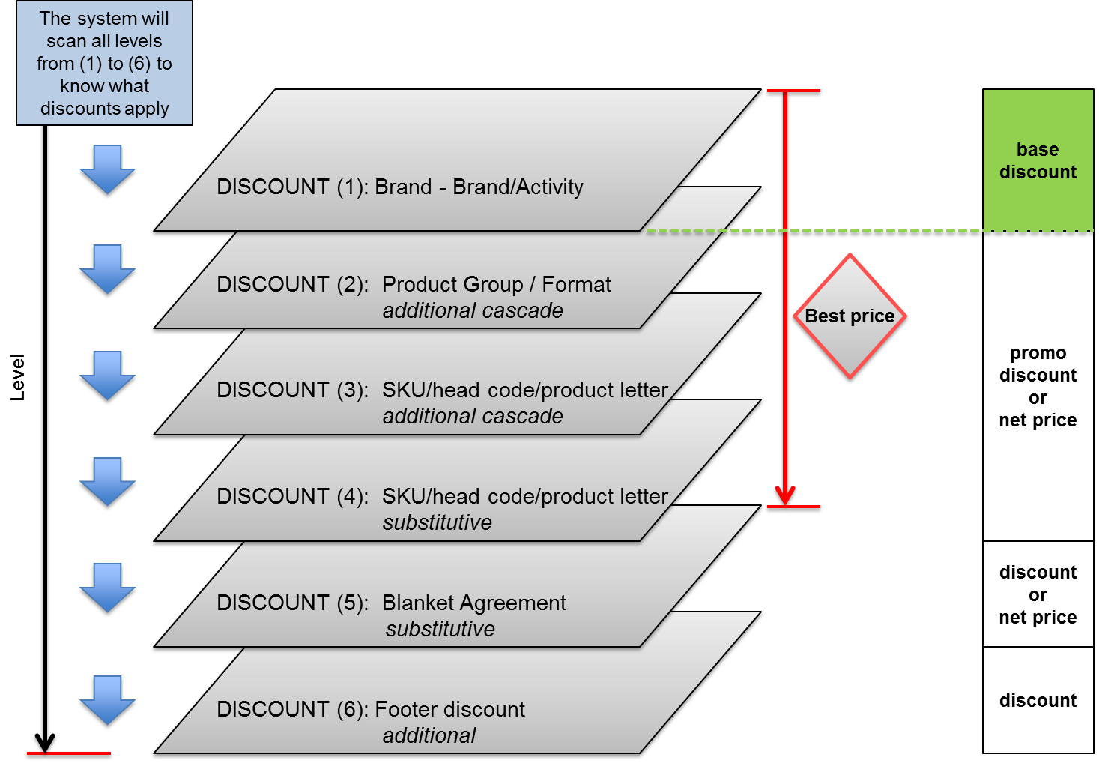

Examples:

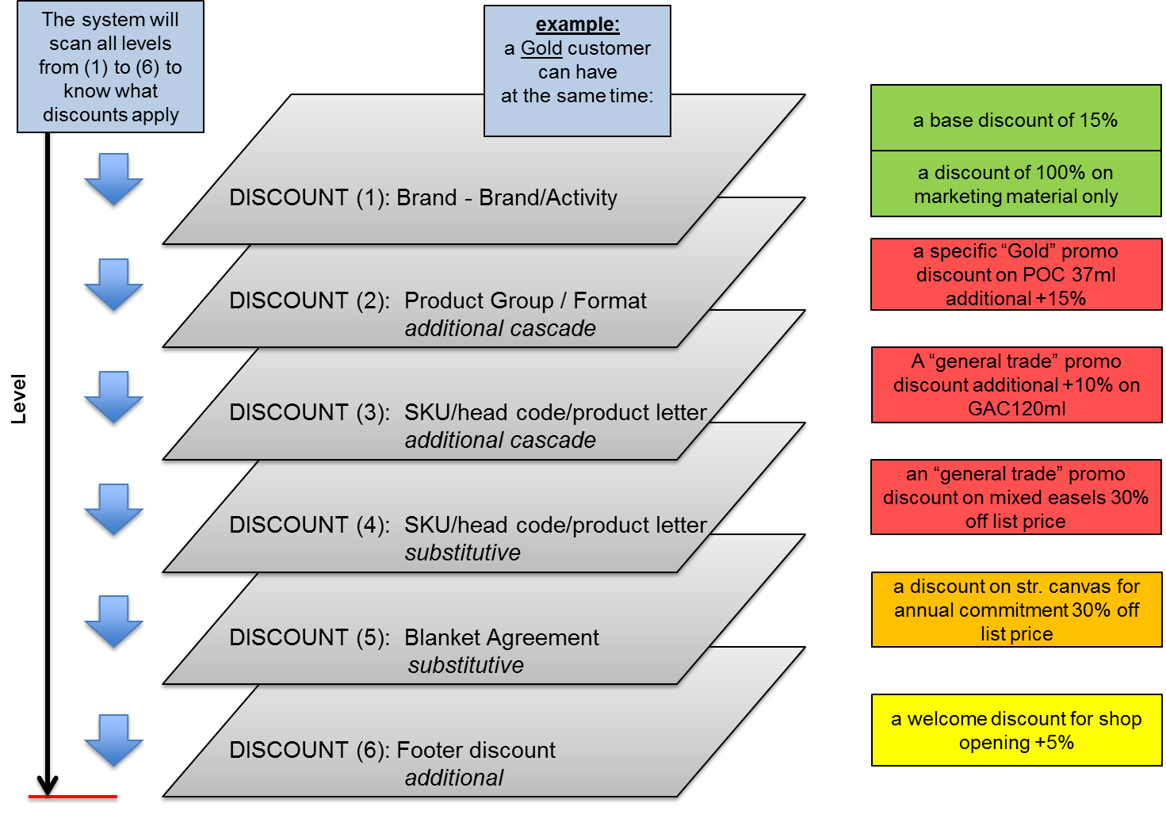

Level (1): base discount, brand, brand/activity

- The discount will apply to a combination of:
  - Customer:
    - Single account
    - Business Chain
  - Product:
    - Brand Type
    - Brand
    - Brand + Activity

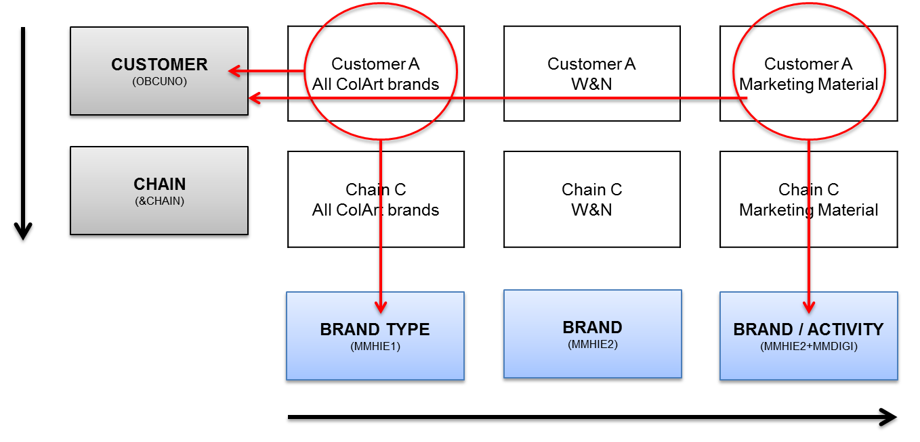

- Example: Customer A has 15% on all ColArt brands but 100% on POS

Level (2): product group/format, additional discount

- The discount will apply to a combination of:
  - Customer:
    - Single account
    - Membership to an advantage programme (Premier Art Center, Privilège,…)
    - Customer Status
    - Business Chain
  - Product:
    - Product Group
    - Format
- The discount is additional cascade

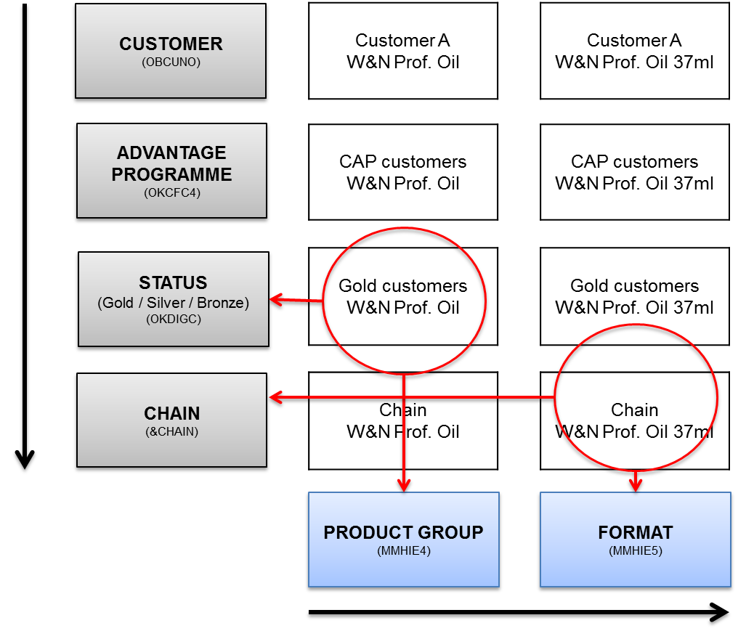

- Examples: Customer A, member of a business chain, has 15% on all ColArt brands (set up at level 1)
  - ex 1: a specific promo for “Gold customers” 10% additional on W&N Professional Oil all series all sizes = 23.5%
  - ex 2: a promotion for a specific chain: 10% additional on W&N Professional Oil 37ml all series = 23.5%

Level (3): head code / SKU / product group, additional discount

- The discount will apply to a combination of:
  - Customer:
    - Single account
    - Customer Status
    - Business Chain
  - Product:
    - SKU
    - Head Code
    - Product Letter
- The discount is additional cascade

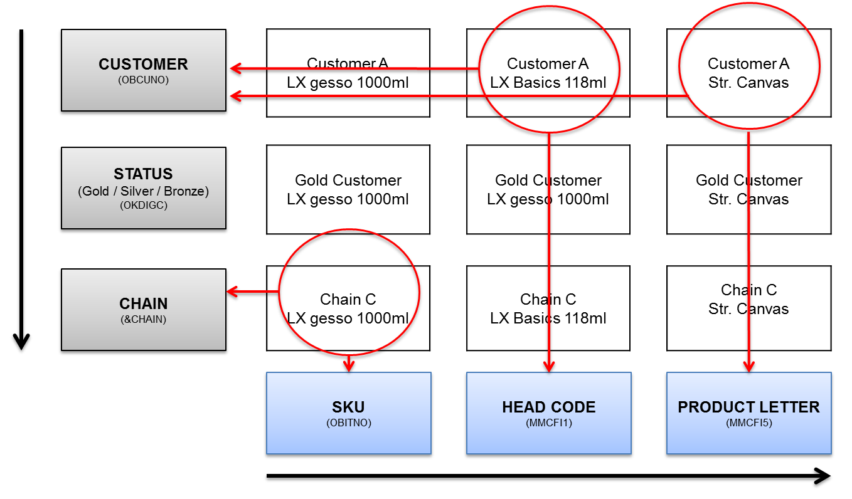

- Examples: Customer A has 15% on all ColArt brands (set up at level 1)
  - “general trade promo” in March: promo Basics 118ml +10% additional for any order of 100 tubes (mixed colours) = 23.5%
  - Chain C promo in April Gesso Liquitex 1000ml +15% for order of 100 pots (=27.8%) / +20% for order of 200 pots (=32%)
  - Customer A, May promo: +15% on str. canvas (product letter) = 27.8%

Level (4): head code / SKU / product group, substitute discount

- The discount will apply to a combination of:
  - Customer:
    - Single account
    - Customer Status
    - Business Chain
  - Product:
    - SKU
    - Head Code
    - Product Letter
- Same as 5.4.4 but the discount supersedes other discounts

- Examples:
  - Promo 25% off list price on Basics 118ml for all “no-chain” customers
  - Promo easels 25% off list price for all Gold Customers

Level (5): blanket agreement

- Products can be identified by 4 possible criteria:
  - the product code
  - the products hierarchy
  - the head code
  - a “product letter” (enables to group inhomogeneous products together (ex: easels)

- The blanket agreement includes:
  - one product or a group of products
  - a discount off-list price on this product
  - a date of application (ex: 1 year)
  - a target volume (ex: x nb of tubes)

- The blanket agreement supersedes any other discount and promotion. It is the lowest price and no other promo discount will apply (except the footer discount, see level (6))
- The actual sales will be reported in the BI and will be followed-up by the Commercial on a monthly basis to ensure the achievement of the targeted volume.
- If the customer fails to reach the targeted volume in the defined period of time, the Blanket Agreement cannot be reconducted

- Example: Customer A has 30% on gesso for an annual commitment of 1000 pots

Level (6): footer discount

- Apply on the whole net invoiced amount
- The discount is additional cascade

Mainland Europe

Overview

List Price
Net Purchase Price
CPP Loyalty
Discount (**)
Trade
Promo
Contract
Prices
ECP Trade
Discount (*)
Blanket
Agreement
Specific
Promo
Back-end

CAP (***)
Promo

(*) European Commercial Policy (ECP)
(**) ColArt Premium Program (CPP)
(***) ColArt Advantage Programme (Premier Art Center, Privileges)

European Commercial Policy (ECP) - Trade Discount

- See Appendix

- The trade discount is defined in a document “European Commercial Policy” which can be published to trade Customers
- The trade discount will apply on invoice
- The trade discount is the accumulation of:
  - The base discount, based on the size of turnover of the previous year (Y-1)
  - The discount for Supply Chain Efficiency
- base discount 2013:

Mini | Maxi | Discount
0 K€ | 3 K€ | 0 %
3 K€ | 10 K€ | 2 %
10 K€ | 25 K€ | 3 %
25 K€ | 50 K€ | 5 %
50 K€ | 75 K€ | 7 %
75 K€ | 100 K€ | 8 %
100 K€ | 150 K€ | 9 %
150 K€ | 200 K€ | 10 %
200 K€ | 250 K€ | 11 %
250 K€ | 500 K€ | 12 %
500 K€ | 1.000 K€ | 13 %
1.000 K€ | 1.500 K€ | 14 %
1.500 K€ | 2.000 K€ | 15 %
2.000 K€ | 2.500 K€ | 16 %
2.500 K€ | 3.000 K€ | 17 %
3.000 K€ | 3.500 K€ | 18 %
3.500 K€ | 4.000 K€ | 19 %
4.000 K€ | 5.000 K€ | 20 %
5.000 K€ | 6.000 K€ | 21 %
+6.000 K€ |  | 22 %

- discount for supply chain efficiency 2013:

 | Discount
Orders sent electronically (see. 2.7) | 2 %
Central payment (min. 5 stores) | 1 %
Central warehouse, cross docking (min. 10 stores) | 1.5 %
Central warehouse, stocking/distri (min. 10 stores) | 4 %

ColArt Premium Programme (CPP) - Loyalty Discount

- See Appendix

- The CPP discount is defined in a document “ColArt Premium Programme”
- The CPP discount will apply on invoice and will be cumulated to the ECP Discount

- Participating Customers will be rewarded by a discount depending on their ColArt Status

- ColArt will define planogrammes by brand by technique
- For each brand and each technique, there are usually 3 levels of planogrammes (A/B/C and in few cases AA/A/B/C or only B/C)
- The planogrammes will include “must have” and “could have” ranges, as defined by ColArt
- The execution of the ColArt Planogrammes will allow customers to collect ColArt Status Points:
  - Plano A: 25 points (AA: 35 points)
  - Plano B: 15 points
  - Plano C: 5 points

- The cumulated amount of ColArt Status Points will define the Customer’s Status and the level of discount:
  - Gold Status 100 points 7.0%
  - Silver Status 70 points 5.0%
  - Bronze Status 40 points 3.0%

Backend (rebate)

- Customers with a net purchase amount of 50K€ or more (excl. Private Label), have access to a rebate based on the growth of their net purchase value from Year (Y-1) to Year (Y):
  - Growth (Y) / (Y-1) = 3.0% - 5.0% 0.5%
  - Growth (Y) / (Y-1) = 5.0% - 8.0% 1.0%
  - Growth (Y) / (Y-1) = > 8.0% 1.5%

- The credit note will be issued the first month of the following year
- Private labels do not count for the calculation of the year-end net purchase amount and are not subject to the defined rebate

USA/Canada

Overview

Trade Discount
Net Purchase Price
CAP (*)
Promo
Trade
Promo
Contract
Prices
Additional
Trade Discount (ATD)
Large Order Discount (LOD)
Specific
Promo
Back-end
(and Partnership For Growth)
List Price (RRP)

(*) CAP: ColArt Advantage Programme

Trade discount

- The Discount to the trade is:
  - 50% off RRP on colours (except exceptions)
  - 70% off RRP on brushes
  - 70% off RRP on paper
  - 60% off RRP on canvas

Additional trade Discount

- The Additional Trade Discount is cumulated in cascade with the Trade Discount
- The level of the ATD depends on the profile of the customer (see appendix for details)

 | RETAILER | PRIMARY RETAILER | PREFERRED RETAILER | MASTER RETAILER | DISTRIBUTOR | MASTER DISTRIBUTOR
 | retail | retail | retail | retail | warehouse | warehouse salesforce
mini full year | 0 $ | 150.000 $ | 2.000.000 $ | 3.000.000 $
ATD | 0.00% | 25.00% | 28.00% | 30.00% | 25.00% |  | 30.00%
Total discount:
Colours | 50.00% | 62.50% | 64.00% | 65.00% | 62.50% |  | 65.00%
Brushes | 70.00% | 76.63% | 76.63% | 76.63% | 76.63% |  | 76.63%
Paper | 70.00% | 70.00% | 70.00% | 70.00% | 70.00% |  | 70.00%
Canvas | 60.00% | 70.00% | 71.20% | 72.00% | 70.00% |  | 72.00%

Large Order Discount

- See appendix
- Orders totaling 4.000 $ or more at dealer net pricing are large order and will receive an additional discount of 20% (2013)
- Some products (ex: non-ColArt manufactured) can be combined to achieve the 4.000 $ but will not receive the 20% discount
- The LOD discount will be extended to promotional programmes but not with any other programme

NB: a customization of M3 will be needed to handle the US LOD

Backend – Partnership for Growth

- The Retail Growth Incentive Programme details conditions to qualify, see appendix
- It is based on direct purchases of all ColArt products

vs (Y-1) | 105-109.9% | 110%
50,000 $ - 749,999$ | 0.75 % | 1.50 %
750,000 $ - 1,499,999 $ | 1.00 % | 1.75 %
1,500,000 $ and over | 1.25 % | 2.00 %

Other Territories

- Are not aligned on the Global Commercial Policy
- The targeted deadline for the countries is their date of go-live on M3
- Export will be linked with the Regional policy on prices and discounts (ex: European export with European Commercial policy

Controlling Processes

- The Global Commercial Policy will be reviewed annually by the Global Commercial

- The Commercial Policy is applied by the CBU under the responsibility of the Manager of the CBU. He will ensure the communication of the Commercial Policy to his team and will keep control of its application

- customers discounts and rebates:
  - are set-up for the first time ahead of the account’s creation
  - are reviewed annually by the Commercial Manager to check if conditions are maintained or if they need to be reviewed
  - can exceptionally be reviewed during the year if the customers profile justifies it

Different tools will be available to measure the performance and the adequacy of prices:

- M3 screens:
  - List prices, contract prices, discounts, sales conditions can be viewed on M3
  - The margin will be displayed at the order entry of a product
  - Records will be kept in the system of annual discount modifications of a customer

- BI cubes will include a wide range of information which can be used for a fine sales and margin analysis of customer groups and products, for example:
  - Product hierarchy
  - Products Data Tags
  - Customer accounts, business chains
  - Customer Status
  - Membership to an advantage programme
  - …

- Standard BI reports will be available to measure business KPIs against objectives:
  - Sales value, margin, quantity
  - PPU, PPML
  - …

Related Areas and Processes

Issue management process

If application of this policy leads to an issue within the business it should first be raised to the respective Policy owner – job title / Name.
Any other information related to issue resolution

Appendix

- European Commercial Policy (ECP), ColArt Premium Programme (CPP) 2013, T&CS 2013

- USA Commercial Policy 2013

