Global Commercial

Document title: | COM003 Order Processing & Inventory Allocation
Document Filename: | COM003 Order Processing & Inventory Allocation
Document number:
Author: | Laurent Dubois
Version: | 1.0
Saved: | Tuesday, 18 March 2014 14:50

Distribution List:
Area | Full Name

Review and Approval Table
Approval Stage | Name | Dated | Approval | Need by Date
Note: The attached document has been provided to you for approval. So that we can stay on schedule, please review the document by the Need By Date, and enter the appropriate approval (listed below):
- Y = Yes, I approve.
- N = No, I do not approve.
- WC = I approve with the conditions shown in my Comments.

Please attach your comments to this document. You may also annotate the document. After you have reviewed and approved/rejected the document, return it to the person who requested the approval.

Change History
Version number | Author | Date | Summary of changes
1.0 | Laurent Dubois | 23.07.2013 | First version

Table of Contents

Global Commercial 1
Global Commercial Policy: Order Processing & Inventory Allocation 3
1. Purpose 3
2. Definitions 3
2.1 Customers and ColArt Distribution Centers 3
2.2 ABC Classification 3
2.3 Associated Services 4
2.4 Large Orders (LO) 4
2.5 Make-to-order (MTO) 4
3. Principles 4
4. ABC Customer Classification process 5
4.1 Classification of customers 5
4.1.1 External Direct Customers: 5
4.1.2 External Export Customers: 7
4.1.3 ColArt Regional DCs and ColArt Subs with local warehouse 7
4.1.4 External e-commerce BTC Customers 7
4.2 Inventory allocation: 8
4.2.1 Make-to-order / specific promotional orders / Private labels 8
4.2.2 Regular orders / replenishment orders 8
4.3 Other Services 11
5. Large Orders (LO) 12
5.1 Large order identification 12
5.2 Make-to-order 13
5.3 Direct Shipment from the factory 14
6. Controlling processes 15
6.1 Review of Customers’ Classification 15
6.2 KPIs 15
7. Related Areas and Processes 15
8. Issue management process 15

Global Commercial Policy: Order Processing & Inventory Allocation

Purpose

The purpose of this document is to define the policy to establish the rules to process orders and inventory allocation, the implications of the Customers’ ABC Classification and how large orders will be handled.

Definitions

Customers and ColArt Distribution Centers

- ColArt Regional Distribution Centers and ColArt Subsidiaries with local warehouse:
  - are ColArt entities locally stocking finished products
  - are serving external customers and - for the DCs - other ColArt entities

- External Direct Customers:
  - are local customers served by the ColArt Distribution Centers or by the ColArt subsidiaries with local warehouse
  - are under the commercial responsibility of a local ColArt Business Unit

- External Export Customers:
  - are 3rd party importers served by the ColArt Distribution Centers
  - have a warehouse stocking ColArt products and are distributing them to their local market
  - are under the commercial responsibility of the Regional Export team (within the export ColArt Business Unit)

- External e-commerce BTC Customers
  - are end-users who buy direct on ColArt e-commerce brands’ web site

ABC Classification

- groups customers into categories so that the business can be focused on the most important customers
- enables adapted behaviors and services directed to each class
- applies to all customers to enable automatic business process

Associated Services

- are the specific services proposed by ColArt for each class of customers

Large Orders (LO)

- will be defined in different cases:
  - specific orders identified as such by the commercial, for ex:
    - new listings for chains and distributions centers
    - specific stock (re)fillings
    - promotions with significant volumes
    - specific volume orders (ex: export tender, annual shipment,…)
  - specific products flagged by the Supply Chain as large volume within a regular replenishment order:
    - volumes greater than a quantity defined by the Supply Chain
  - orders of identified customers:
    - customers with annual order and large volumes
    - specific customer/product
    - private label

Make-to-order (MTO)

- Manufactured products can be produced for a specific order = make-to-order
- The MTO will be used in different cases of Large Orders (see 5.). A specific lead-time will be defined by the Supply Chain (after checking capacity with operations, supply orders, etc…) and will be confirmed to the customer by the commercial

Principles

- a simple and common approach for classifying customers
- clear rules which will avoid bargaining and which will improve the efficiency of the order processing and of the Supply Chain execution
- a prioritization of customers on line with ColArt business objectives
- a similar impact for customers of the same category and served by the same ColArt warehouse, independently from their country

ABC Customer Classification process

Classification of customers

External Direct Customers:

- The classification of customers is done by each ColArt Business Unit (CBU) for all its customers with validation by the Global Commercial

- The ABC Classification is defined in 4 steps:

  - (1) calculation of the 20/80:
    - basis = net amount of sales of the previous year
    - different accounts of the same chain are grouped together as 1 customer
    - pre-ranking of customers in 3 categories from the #1 biggest customer to the smallest:
      - “A” customers: cumulated sales = 80% of total sales
      - “B” customers: cumulated sales = 15% of total sales
      - “C” customers: cumulated sales = 5% of total sales

Pareto Diagram:
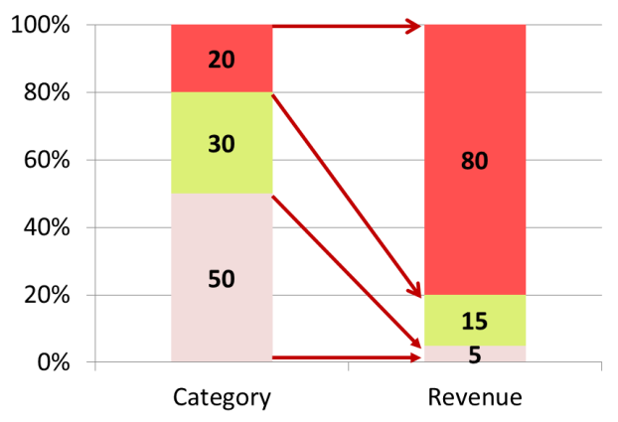

    - adjustment according to minimum size of revenue by category:
    - “A” customers: mini 25K€
    - “B” customers: mini 10K€
    - “C” customers: no minimum

- (2) local input on the customers’ ranking:
  - customers can be upgraded or downgraded according to their strategic importance
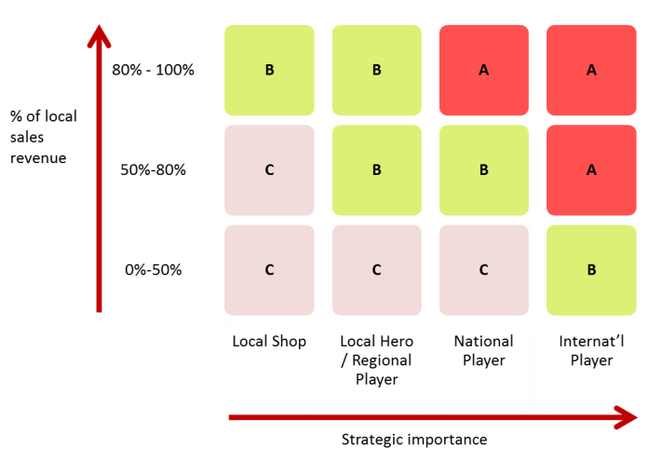

- (3) validation by the Global Commercial:
  - “A” customers with a net purchase amount of 100K€ or more will be classified as “AA”. They are the Group’s top customers
  - the classification done by the local commercial entities will be validated by the Global Commercial
  - amendments can be done by the Global Commercial according to the Groups business objectives

  - (4) set-up/up-date of the Customers’ data:
    - The ABC Classification is identified as a field in M3
    - This field will be updated by the local Customer Service in the customers’ creation/modification form

- customers’ chains / buying groups:
  - by default members of a Chain are classified at the same level as the Chain
  - however, the CBU can decide to downgrade some customers of a chain if their classification is not judged as relevant

- customers’ warehouses:
  - as they should keep a buffer stock and are rewarded as such with a specific discount, the Distribution Centers or the Regional Warehouses of customers can be downgraded vs. the members of the chain which are delivered directly by ColArt
    - ex: a shop can be classified as “A” but the Central Warehouse can be classified as “B”

External Export Customers:

- External Export customers keep a buffer stock and will therefore be positioned in the “B” and “C” classifications and cannot be classified as “A” customers
- The process for determining the classification of the External Export Customers will be based on a Pareto analysis and completed after the following criteria:
  - B: top 20% of the export customers
  - C: other export customers
- If customers shall be classified differently, a judgment call will be made by the CCO

ColArt Regional DCs and ColArt Subs with local warehouse

- ColArt entities served by other ColArt entities will be classified as “B”

External e-commerce BTC Customers

- End-users who are buying directly on ColArt brands’ web sites will be at the highest level of priority
- They will be classified as AAA customers (unless they are served by a specific warehouse, TBC)

level of priority  (from the highest priority to the lowest) | class | comment | M3 codification  (field OKPRIO)
1 | AAA | en-users (BTC) (*) | 2
2 | AA | top selection of the A customers (>150K€) | 3
3 | A | 20/80 accounts by country (>25K€) | 4
4 | B | 30/15 accounts by country (>10K€) | 6
5 | C | 50/5 accounts by country | 7

(*) to be confirmed, not valid if 2 different W/H for BTC and BTB

Inventory allocation:

Make-to-order / specific promotional orders / Private labels

- large orders and specific promotional orders which have been defined in advance (ex: gift sets) and produced on the basis of customers’ purchase forecasts (make-to-order) are not in the scope of the automatic allocation and allocation by customers’ ABC classification
- the allocation is then made automatically after being confirmed by the Supply Chain: the customer order is linked to a work-order and cannot be allocated to any other customer
- see point 5.

Regular orders / replenishment orders

- window of allocation:
  - the window of allocation enables to calculate the lead-time between the allocation of the product line and the date of its departure
  - the window of allocation starts 5 days before the expected date of departure
Example: admin (CS/AR): 1 day, pick & pack 2 days, transport 1 day

Expected
date of
delivery
transport
1 day
Date of
departure
pick & pack
2 days
admin
1 day
Allocation
starts
window of allocation: 5 days
Date of
planning
2 days
route: 4 days
Order creation
Internal lead-time

- If the order is placed for immediate delivery, the route will apply and the inventory will be allocated immediately (already in the window of allocation)
- If the order is placed in advance, the inventory will be allocated 5 days before the expected date of departure (3 days before the Pick & Pack starts)

- routes: the routes are currently the following:
  - French orders:
    - France North: 4 days = CS/AR: 1 day + logistic (pick & pack) 2 days + transport 1 day
    - France South: 5 days = CS/AR: 1 day + logistic (pick & pack) 2 days + transport 2 days
  - Europe direct customers:
    - Italy 5-6 days: CS/AR: 1 day + logistic (pick & pack) 2 days + transport 2/3 days (/area)
    - Spain 6-11 days: CS/AR: 1 day + logistic (pick & pack) 2 days + transport 3-6 days (/area)
    - Other future direct deliveries: routes to be defined
  - Europe Export: route = w/o transport
    - Near European countries: logistic (pick & pack) 2 days
    - Other European countries: logistic (pick & pack) 4 days
  - Export outside Europe: route= w/o transport
    - logistic (pick & pack) 6 days

Example: orders entered the same day (D1), due date at the same day (D3), window of allocation 5 days before due date (D2) (example of French customers)
- order #1: A customer, 20 pcs
- order #2: A customer, 15 pcs
- order #3: B customer, 10 pcs
- order #4: C customer, 6 pcs

- case 1: product available on stock:
  - it is automatically allocated according to ATP rules in M3 (ATP = Available To Promise (DAV) = next date of availability after current orders): when entering the window of allocation, the product is allocated in the ranking of the orders (first in first served)
  - the ABC Classification has no impact on allocation

allocation:
order #1 : 20 pcs
order #2 : 15 pcs
order #3 : 10 pcs
order #4 : 6 pcs
stock 100 49 pcs
D1
D3
D2
window of allocation
orders

- case 2: product Out Of Stock (OOS):
  - the ATP rule gives an indication when the product is theoretically available after all previously entered orders have been served
  - when entering the window of allocation, the inventory is allocated in priority to A customers, then B customers, then C customers
  - the ABC does not de-allocate a product which is already allocated to a customer
  - implication: potentially, an A customer will get products before a B customer even if he has placed his order after

Ex: available stock is 40 pcs at D2

allocation :
order #1 : 20 pcs
order #2 : 15 pcs
order #3 : 5 pcs
order #4 : 0 pcs
stock 40 -11 pcs
D1
D3
D2
window of allocation
orders

- manual intervention / workaround:
  - inventory de- / re-allocation:
    - can be done exceptionally by the Global Customer Service only (for customers served by Le Mans warehouse)
    - only after judgment call by the Global Customer Service and the Global Commercial (CCO)
    - shall remain the exception and shall be as much as possible avoided as it is disturbing the automatic ATP process

  - modification of classification for a single order (an order can exceptionally be handled in a different way as the customer class would direct):
    - can be done exceptionally for customers served from Le Mans warehouse only by the Global Customer Service
      - only after judgment call by the Global Customer Service/Global Commercial
      - ex: an order of a “B” customer can be handled as an “A” order
      - ex: some export orders, ex letter of credit
    - can be done exceptionally for local customers served by a local warehouse to secure specific local orders (ex: new placements)
    - shall remain the exception

Other Services

- at this stage, no other service is linked to the ABC class
- the order flow through the warehouse is not related to ABC classification:
  - it is depending on the optimized order sequencing in place for a defined group of customers (ex: Spanish customers)
  - the order sequencing will be based on how many shipments per week and the best date/time set to place the order for an optimized order processing (customer service, logistics)
- specific priorities in orders processing as well as differentiated prices for offered services can be implemented at later stages

Large Orders (LO)

Large order identification

- Large orders (LO) are identified by at least one of the 3 following criteria (see point 2.4):
  - Automatic flag in M3: at least one of the ordered lines hits a level defined by the Supply Chain (qty)
  - Automatic flag in M3: any order of specifically identified customers (annual order, private label)
  - Anticipated flag: specific LO identified as such and in advance by the commercial (ex: new listing)



Supply chain
large
order
Customer
Service
Operations
Customer
- Leadtime
- Quantity
Commercial

- Process path:
  - Anticipated LO will be communicated by the Commercial (CBU) to the Supply Chain for feedback (copy Customer Service for information)
  - Other large orders will be entered normally and will switch automatically in M3 in a preliminary status (status 10)
NB: if at least 1 of the ordered line is flagged as a large order, the whole order is automatically put in status 10

  - The Supply Chain will check the stock and the supply planning with operations and will confirm within 24 hours the date of availability to the Customer Service (new date or unchanged date) and the process (MTO / non-MTO, see 5.2).

  - The Customer Service will confirm the lead-time to the customer only after feedback from the Supply Chain. The customer will be asked to validate the order with the new lead-time
  - After final confirmation, the Customer Service will approve the preliminary order by:
    - Validating the lines using the standard process for all non-MTO
    - Validating the lines and creating automatically chain of orders for MTO lines

Make-to-order

- Make-to-order will be used for some identified large orders (for ex: if quantities are equal or greater than the minimum production batch quantity of this product)
- The required quantity will be specifically produced for this order – or together with a standard batch production - and will be tightly linked to the customer’s order in M3
- The inventory is then dedicated to this order and cannot be allocated to any other customer order
- The order does not affect the regular stock inventory and goes out of scope of the forecasts

- Unless signed-off by the CCO, Private Labels will be produced on demand and will be handled as a MTO with a specific lead-time:
  - no permanent stock of Private Label
  - conditions to be clearly indicated in the contract with the customer

- MTO applies for manufactured products. For supplied products, the lead-time will be defined after feedback from the supplier

- In a single order it may happen that only some lines are flagged as large order and submitted to MTO. In this case the whole order will be re-positioned at the later date unless the customer confirms the split of the order in 2 shipments:
  - If the order is positioned at one single date:
    - The MTO production will be linked to the customer’s order (cannot be taken by any other customer)
    - The rest will be allocated and secured until the date of availability of the MTO so that the order is then complete
    - Implication: these orders must be excluded from the OTIF KPIs as:
      - The initial date must be maintained to allow and secure allocation
      - The actual shipment will by consequence be “late” vs the initial date (even it has been approved by the customer)
  - If the order is split in 2 deliveries (1 for MTO, 1 before for the rest):
    - The MTO production will be linked to the customer’s order
    - The rest will be allocated as a regular replenishment order
    - freight charges will remain at his charges if the value does not hit the free freight minimum

Direct Shipment from the factory

For large orders, if the quantity coincide or exceed the batch quantity, it may be relevant to organize a direct shipment from the factory to the customer.
- The Supply Chain will make a judgment call and will direct where the goods are to be shipped from in order to optimize the lead-time, the freight costs, the stock level.
- The Supply Chain will coordinate the supply to the customer – potentially from different places and run it on a project mode:
  - a clear planning will be produced highlighting the deadlines which might affect the final delivery date (ex: date of final confirmation from the customer to allow production & shipment and hit the targeted delivery date)
  - the Supply Chain will chase the Commercial if any feedback is required
  - the commercial CBU shall chase the Supply Chain to get information and secure the delivery according to plan.
  - Any red flag – by the Commercial or by the Supply Chain - shall be escalated to the CCO/COO to make the best decision to serve the order on time

NB: a similar process can potentially be organized between ColArt warehouses (to rebalance stock between locations for ex.)

- Examples:
  - New placements from the US and China to Clas Ohlson, Sweden
  - Merchandising material from the supplier in UK to Kidderminster for the UK market



Customer
Europe Logistic DC
China Logistic DC
Le Mans Manufacturing
Tianjin Manufacturing
Usual flow
Large Order flow

Ex, Clas Ohlson (SE)

Controlling processes

Review of Customers’ Classification

- the Customers’ ABC Classification is static and will be reviewed annually by the commercial entities
- the review shall be completed by the end of January for implementation / update in February
- the classification of a customer can exceptionally be reviewed during the year if an important change of its profile justifies it (ex: if a customers is integrating a chain or if 2 customers are merging). A specific form will need to be completed by the local commercial entity to explain the reason for changing the classification.
- ABC Customers classification must be approved by the CCO

KPIs

- BI reports will be set-up and will enable the follow-up of the service level by country for each class of customers. These reports will be defined in a separate policy (see Global Commercial Management – Policy on Service Level Reports)

- Service level, lead-time

Related Areas and Processes

- Supply Chain Execution
- Supply Chain Planning
- Operations

Issue management process

If application of this policy leads to an issue within the business it should first be raised to the respective commercial entity Manager.
If an issue still exists then it should be raised to the global function head for final resolution.

