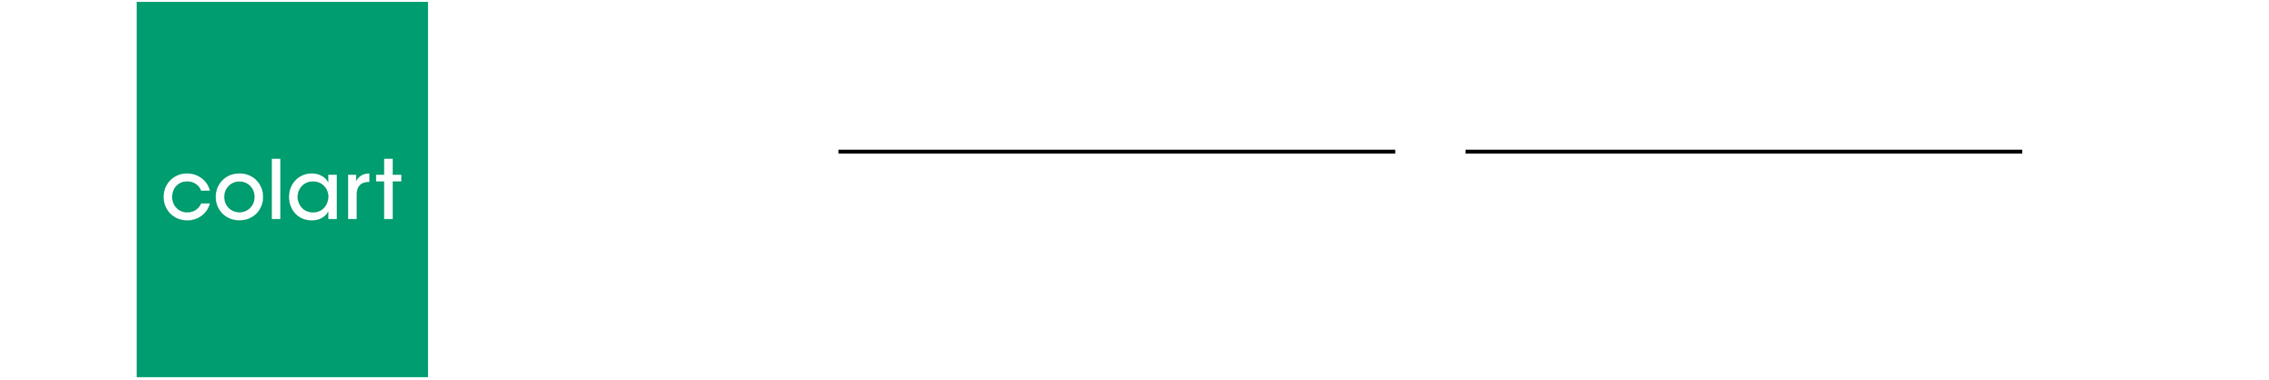

London
29 September 2017

Donation Feedback Form

Return to:
sustainability@colart.co.uk
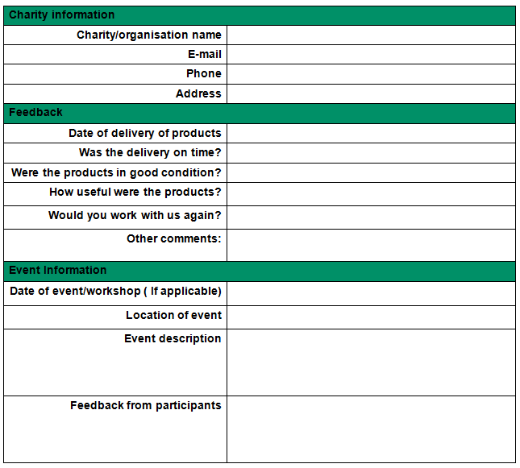

If the products are not being used for a specific event, please give an overview of how the products were of use to you.

We would love for you to enclose photos from your event. If you do enclose photos from your event you confirm:

- That you are the owner of all rights in the photos you enclose and that you give permission to members of the Colart group to use those photos in promoting our donation programme and other activities of the Colart group (whether in print, online or otherwise)

- (That you have obtained permission from any people who appear in your photos for the images to be used in this way.

