Functional Area

Document title: | Finance 007 - Capital expenditure Policy
Document Filename: | Finance 007 - Capital expenditure Policy
Document number:
Author: | Gordon Roper
Version: | 1.0
Saved: | Tuesday, 10 March 2015

Distribution List:
Area | Full Name
Central Brand Team | CMO – Lotta Edstrom
 | GMD W&N – Ben Hovanessian
 | GPD Liquitex – Anita Langley
 | GMD Reeves & Lefranc & Bourgeois – Richard Black
 | GMD - TBC
 | I&D - Paul Lamoureux
Global Operations | COO – Gordon Roper
 | HOL – Diego Mombelli
 | GM Le Mans – Claude Payen
 | GM Tianjin – Roger Yan
 | GM Lowestoft – Richard Llewellyn
 | GM Minehead – Adrian Ryan
Global Commercial Team | COO - TBC

France Thierry Collot

Spain Pilar Bringas

Italy Philippe Bonenfant

Germany Norbert Schmitt

Netherlands Piet Van Nassau

Sweden Tommy Ruponen

UK Clive Watson

Export TBC

USA Doug Johnston

China Jim Yang

E commerce Fleur Meurer

Central | CEO – Thomas Brautigam
 | CFO – Christian Thieme

Review and Approval Table
Approval Stage | Name | Dated | Approval | Need by Date
Approver: | Christian Thieme
 | Thomas Brautigam
Note: The attached document has been provided to you for approval. So that we can stay on schedule, please review the document by the Need By Date, and enter the appropriate approval (listed below):
- Y = Yes, I approve.
- N = No, I do not approve.
- WC = I approve with the conditions shown in my Comments.

Please attach your comments to this document. You may also annotate the document. After you have reviewed and approved/rejected the document, return it to the person who requested the approval.

Change History
Version number | Author | Date | Summary of changes
1.0 | 1.0 | 17.03.14 | First version

Table of Contents
Functional Area 1
Policy: Capital Expenditure Policy/ Capital Investments Policy 4
1. Purpose 4
2. Principles 4
3. Capital investment process 5
3.1 Outline budget approval 5
3.2 Investment proposal sign off 5
4. Controlling processes 6
Appendix 8

Policy: Capital Expenditure Policy/ Capital Investments Policy

1. Purpose
The purpose of this document is to define the policy and process to manage our Capital investments (CAPEX) in line with our “GET WISER” sustainability approach.

2. Principles
The following principles have been considered in determining this policy:

- A simple and common approach
- Clear governance & authorization of spends
- Align the process to ensure sustainability “GET WISER” approach forms part of our day to day business decision making process
- Financial payback on investments of less than 2 years desired

3. Capital investment process
Approval for capital investment occurs in two phases:

- Outline budget approval
- Investment proposal sign off

3.1 Outline budget approval

Outline approval for investments is obtained during the budget process. Where each business is expected to create a list of CAPEX requirements for the budget year. Stating value & category of investment and savings and payback expected and ensuring that these are necessary to meet their business plan objectives.

Standard list to complete:
A version of the list can be seen in “Standard Capex approval form & Process_v2.xls” on the sheet tabbed “Governance_Budget Approval Form" (see file in appendix 1)
Where the proposed amount is above £20,000 then the following forms need to be completed in sufficient detail available at that point in time in the budget process:
- Governance Form1; a .xls governance sign off sheet
- Economics Form2; a .xls sheet summarizing the investment amounts and payback period
- Capital investment proposal document (word) providing the justification behind the proposal

Any projects from the previous year that have been approved but where no commitment to spend has taken place must be re submitted as part of the new budget process.
Chief Operations Officer (with GMT) will give a budget approval or not on a case by case basis and communicate this to local entity.

3.2 Investment proposal sign off

Before any actual spend is committed the spend needs final approval.
To obtain final approval all of the forms need to be completed and submitted for signature in line with the approval limits:

To approve an investment, each spend needs to have Governance Form 1, Economics Form 2 and the capital investment proposal completed and signed off according to the aforementioned limits.

Completing the Governance Form 1, is self explanatory. However please note that there are 7 drop down boxes on the form which will indicate how well the proposed investment meets our “GET WISER” objectives. If the investment positively supports and improves our position in this area please select “Green”, if no change from today then select “Yellow”, if situation would deteriorate from today then please select “Red”. Please note that any “Red” selection will invoke detailed questioning and would risk eventual sign off and approval unless full justification can be provided and no other alternative exists. Note there is no check list for “Governance” as this is ultimately covered by the investment form being signed off.

Controlling processes

A hard signed off copy of the governance sheet will need to be stored in the business unit and also in HQ by the Group Financial Controller.
Each business unit is expected to update the status of their CAPEX budget list on a quarterly basis as part of the rolling budget review process.
A post investment audit review will also be conducted to ensure that the investment made achieved the objectives defined in the capital investment proposal and to gain any relevant learning’s.
A simple share point list has been created to hold all the relevant information regarding the CAPEX such as scanned signed copies of the approved paperwork and justification documents, suppliers quote information etc. List can be found on the operations COLORS home page under lists, CAPEX Log
Sharepoint site address is:
http://one.colart.com/colors/Lists/CAPEX%20Log/AllItems.aspx?ShowInGrid=True&View=%7BE94005BB%2D4214%2D4B7A%2DAC0E%2D06D0DB96D146%7D&InitialTabId=Ribbon%2EList&VisibilityContext=WSSTabPersistence
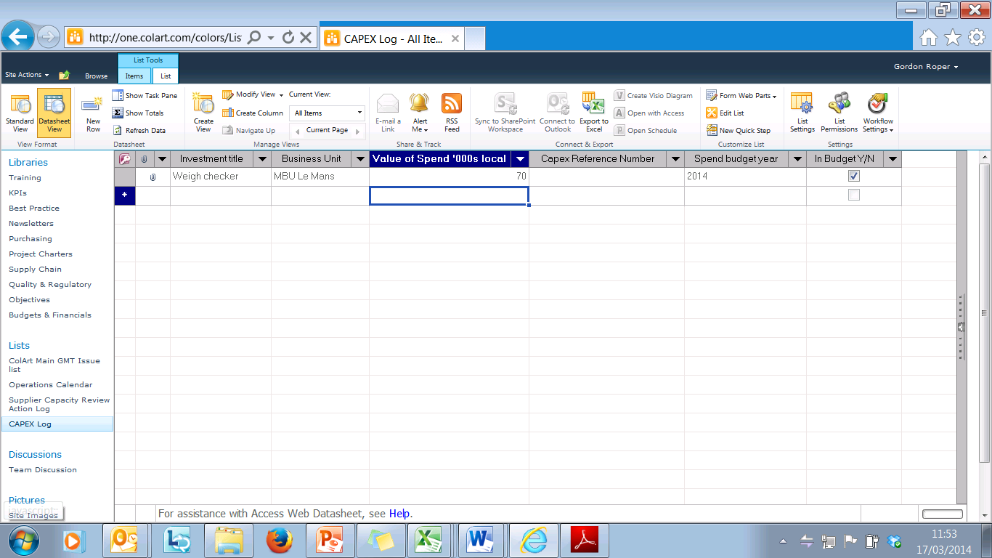

Appendix
APPENDIX 1: CAPEX Budget Approval Form, Governance Form1 & Economics Form 2

APPENDIX 2: Capital investment proposal document template

