News Story Request Form

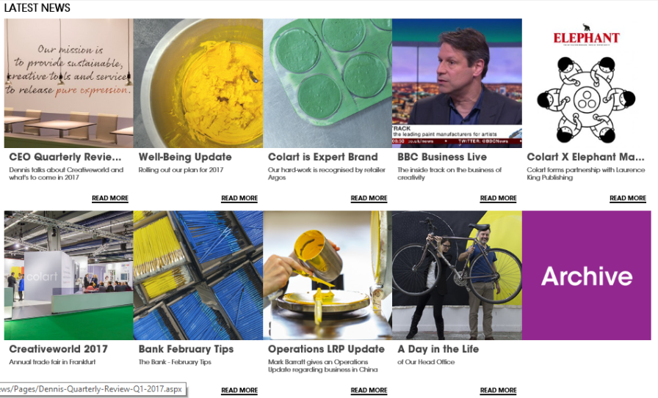

Categories | Your input
Type(s) of announcement required | ☐ Intranet Article  ☐ PDF  ☐ Specific Email
Title  Short and snappy | Click here to enter text.
Subtitle  What is the article about? | Click here to enter text.
Date of Publication | Click here to enter text.
2-line Overview  Short article Summary | Click here to enter text.
Article  Around 500 words | Click here to enter text.

Please attach a maximum of 5 pictures.
If you have any question please email Lucie or Sophia

