What is m-Power?
M-Power is an application development tool. It is used to create data-driven Web applications. For Colart, we use it for reporting M3 data as well as links to our WMS’s in the UK and the US which is all real time data extraction.
This tool has been used in the business for the last few years but is not as widely used as it could be. We would to re-introduce MRC Reporting to Colart users globally.
You log into the applications using your windows username and password.
TOP TIP: This only works in IE and Chrome, not in Edge. And if you are accessing it from home, you will need to be connected to the VPN.
There are two main types of applications – Reports and Retrievals.
Retrievals
A retrieval is an on-screen lookup and is used for getting large amounts of data very quickly but only showing a small subset of data per page. This makes the data load extremely quick. Retrievals come with, pre-loaded, advanced sort and advanced search which means you can filter on any of the fields within the report.
Below is an example of a retrieval with Product Standard costs, there is a lot of data (143, 273) but it loads in seconds because it only displays 100 rows per page. You can use the advanced sort on each column by using the arrows.
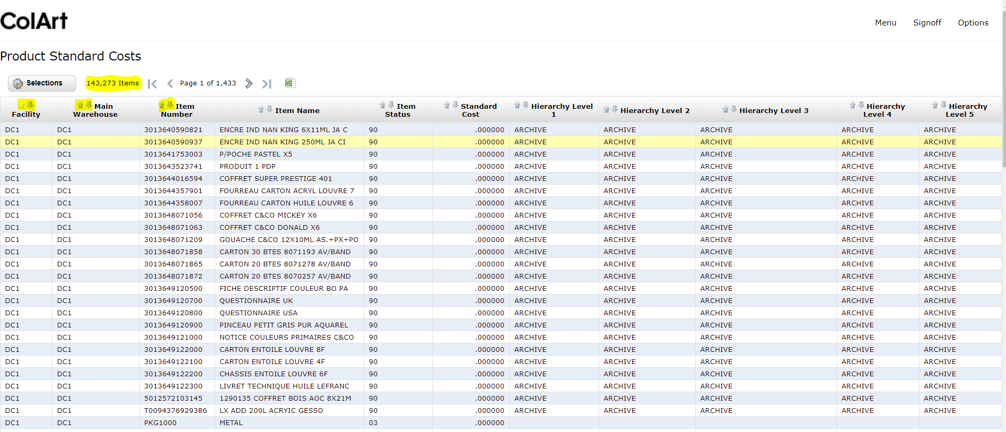

You can then filter on any of the columns by clicking selection and using the dropdown for Relationship to get the data you are interested in – For example, Equal to, Starts with, Is in the list etc. Once you have made your selection, the number of records change, for Example Arches has 591 Items.
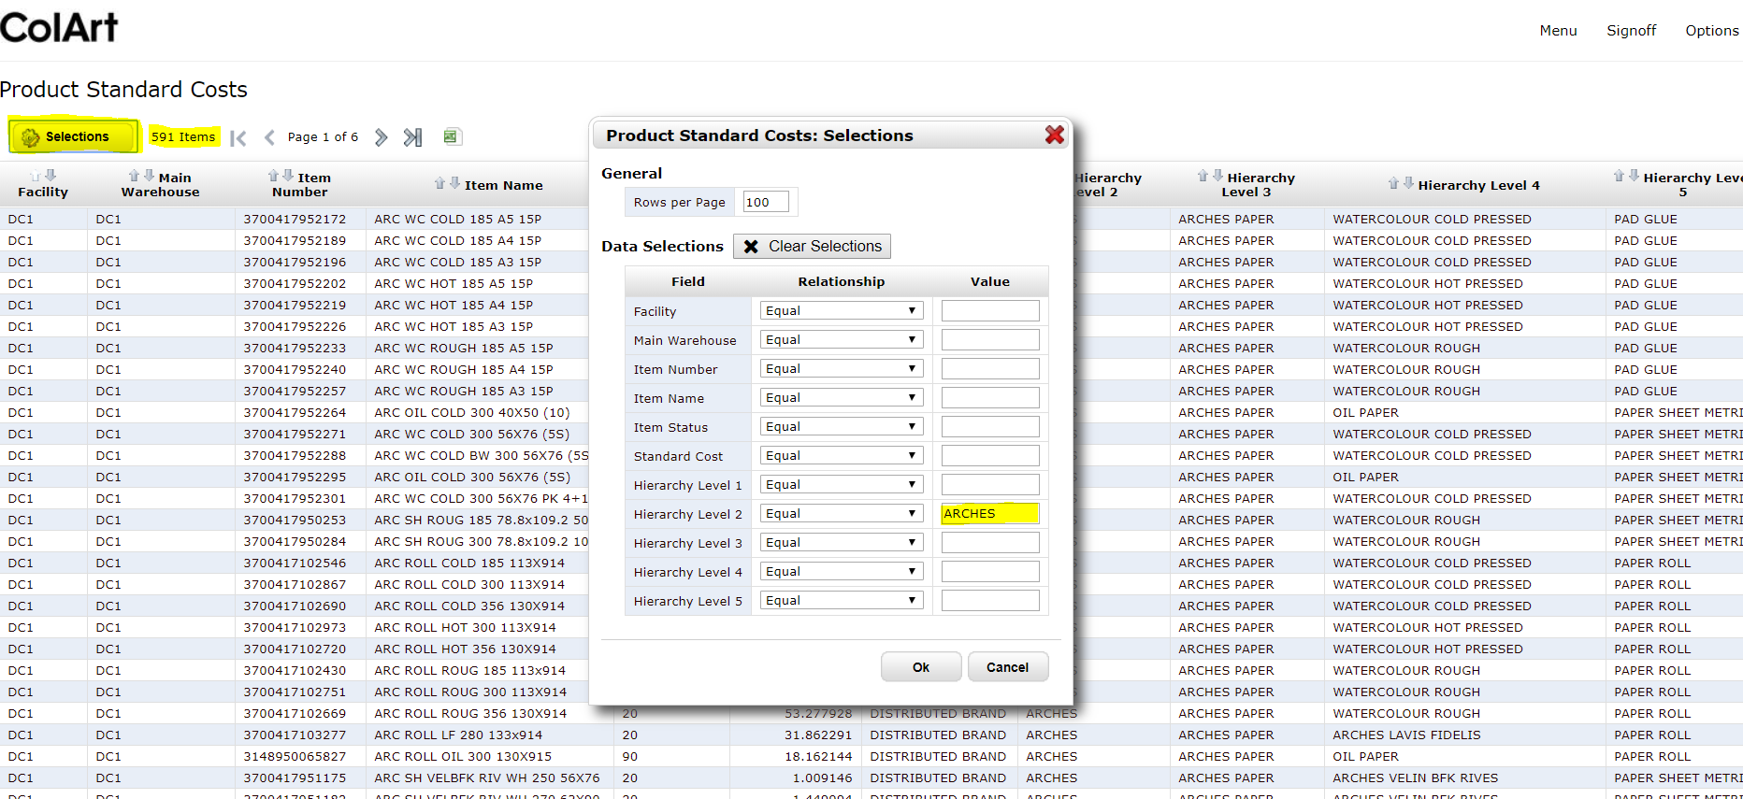
If you want to export this selected data, there is a small excel button. You then have to change your rows per page to get all the data. So, for Arches, you change the Rows per page from 100 to 600, click on the excel icon and you will get all the data needed.
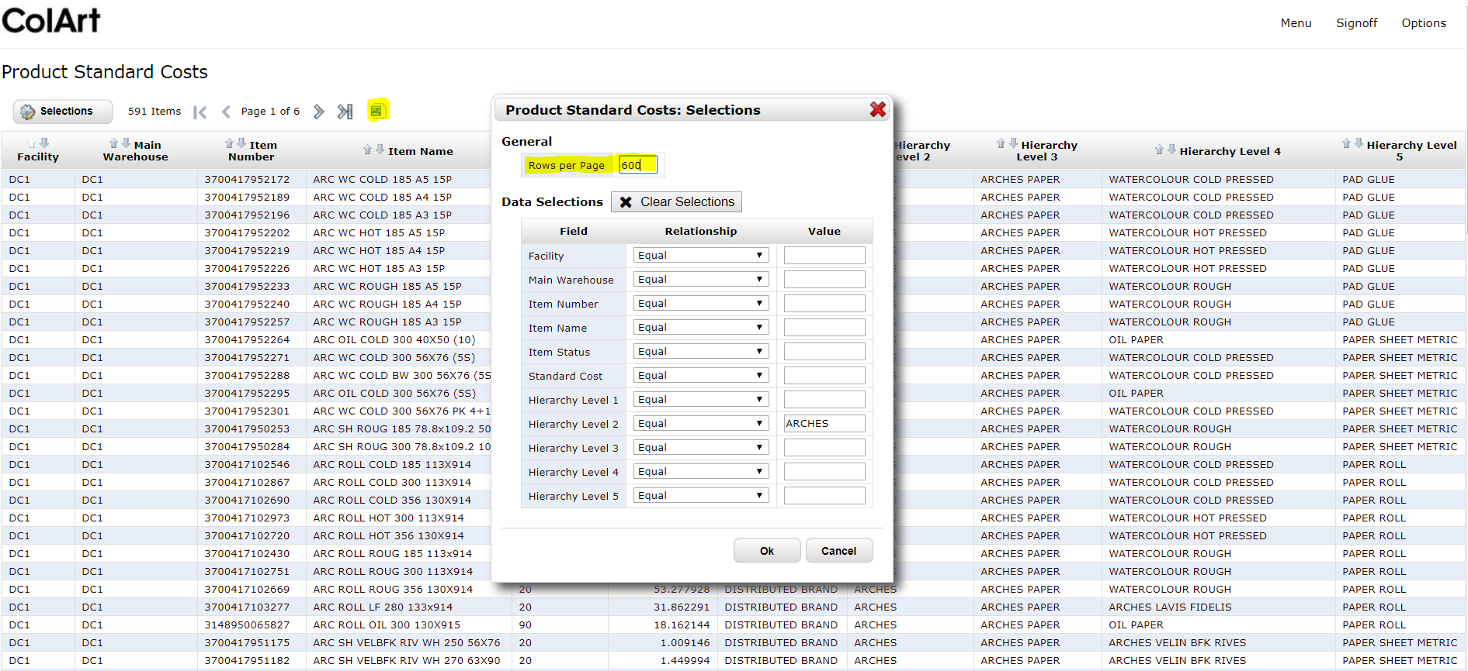
At runtime, it is possible to sort on more than one field via parameters in the URL, this eliminates the need for multiple applications. It is useful for showing the report in different ways, especially if you need the same selection each time.
The URL parameters that control the sorting are:
- sort_typ= a value of 0 will sort in descending order, a value of 1 will sort in ascending order.
- cur_sort_col= list of comma separated fields, the order of the fields will match the order of the values for sort_typ. First value in sort_typ will correspond to the first field name in cur_sort_col, and continue with the rest of fields in the order they are included.
- reorder=Y tells the program that reorder sort parameters are being passed.
The link will look like this:
MRCCOLART.I00010s?sort_typ=0,1&cur_sort_col=FIELD1,FIELD2&reorder=Y
FIELD1 = the name of the field in your application
FIELD2 = the name of the field in your application
NOTE: these parameters are case sensitive, make sure to use the same case sensitivity as in the example.
Reports
A report is different to retrievals as it is smaller files, reports query the database and return all at one time. The reports generally have a limitation of 10,000 but this can be amended if needed. When a report is run, the prompt page is opened by default.
There is an option to filter on certain criteria. The runtime value prompts allows users to input a value at runtime, creating a dynamic data selection. The Selection Criteria panel displays all runtime value prompts for the report.
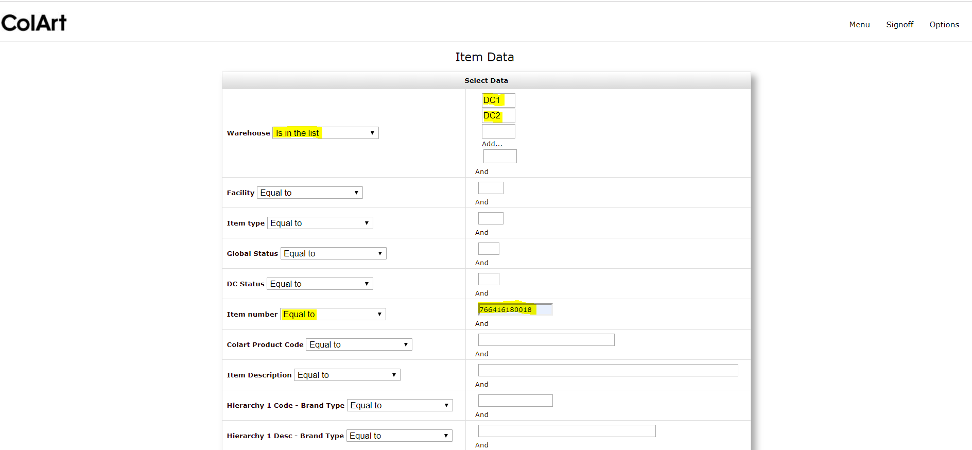
If you want to change this selection while displaying in HTML, you can use the Make Additional Selections button to get the data that you require.
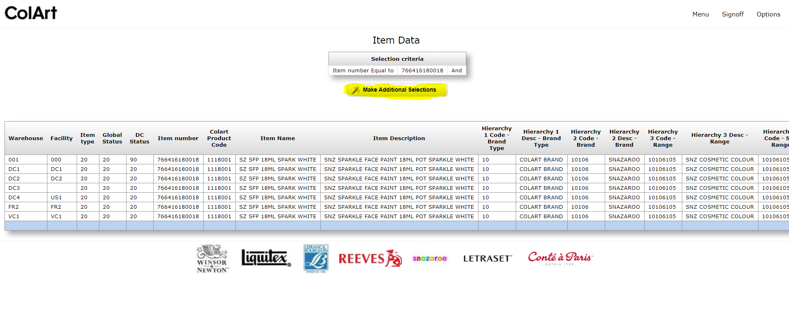
A Report calculates sub-totals and grand totals for selected data so based on your needs. You can look at the detail of the lines, the subtotals or totals of a given selection. This feature is used for analysis reports where totalling is needed. For example this Report has a few different subtotals. Note that detail levels are displayed above subtotal levels, and the grand total level is at the bottom of the table. You can choose to display one or all three of these options.
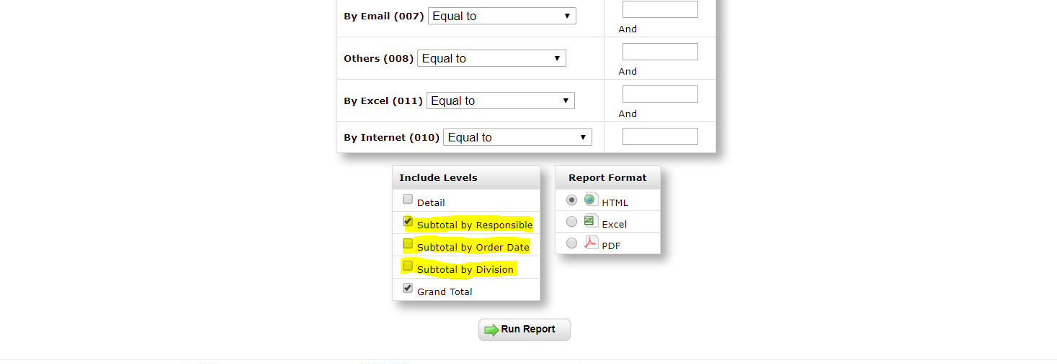
Reports allow you to specify the different output formats. At the bottom of the page, you can choose HTML, Excel or PDF.
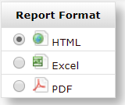
Reports can also be scheduled running reports at off peak times or be emailed directly to you with your selected criteria for example, you can see all of yesterdays’ sales orders for your division.
Reports can also be executed using the URL, for when you want to skip the prompt page and go straight to the results. You can do this by adding ?run=2 to the URL Line. The page will run with the defaults from the prompt page.
Here are some options for Ad Hoc Reporting
http://172.16.1.111:8011/mrcjava/servlet/MRCCOLART.RXXXXs?run=1&R001=76641610018&D_DETAIL=0&S_CUSNO=1&G_TOTAL=1&outfmt=11
RXXXXXs — Executable report program number
? — This is the indicator that there are parameters being passed to the RXXXXXs program
run=1 — Indicates to the program to bypass the prompt page and default settings, and to instead use the parameters which follow
& — This is a deliminator between parameters being passed
R001=76641610018 – This is the number of the selection and the value, for example R001 is the Item Number selection and 76641610018 is the value.
D_DETAIL=1 — Specifies to include detail level in the report
S_CUSNO=1 — Specifies to include the subtotal by the field CUSNO (customer number) that the report is sequenced by
G_TOTAL=1 — Specifies to include grand total in the report
outfmt=11 — Specifies the output format in which the report will be generated, PDF in this case
Output Formats:
outfmt=0 — HTML
outfmt=1 — Print Optimized HTML
outfmt=4 — XML
outfmt=11 — PDF
outfmt=12 — CSV
outfmt=13 — True Excel (.xlsx)
outfmt=14 — Text File (.txt)
outfmt=15 — Optimized Excel (.xlsx)

