May 2020
London

Fire & Emergency Evacuation Plan

- Action in case of fire

- The responsible person for the site at The Studio Building will be Colart’s Chief Executive Officer and, in his absence, the Senior Fire Warden will act as the responsible person with the support of the Fire Wardens. In the absence of the Senior Fire Warden, the Deputy Fire Warden will assume responsibility. Each Fire Warden has a Deputy appointed who will assume responsibility in their absence, as per the Fire Organisation Chart (attached). The Senior Fire Warden will liaise with the Fire Authority on their arrival to the building.

- For the purpose of evacuation in the event of a fire, the fire alarm is connected throughout all buildings and will sound site-wide. The alarm is a continuous siren.

- All rooms and corridor areas are fitted with smoke detectors. When activated (by operating a call point or as a result of smoke or heat detection) the alarm will sound.

- No one should fight a fire unless required to allow exit from the building. Fire extinguishers are strategically positioned on all floors occupied by Colart and in stairwells of the building to assist escape only.

- The fire alarm is a continuous siren. It is essential that all persons respond immediately on hearing the alarm and evacuate the building in an orderly manner. All persons should leave the building by the nearest safe fire exit and go to the designated Assembly Point (the raised grass area in the park on Hunt Close; see map attached) and await further instructions. All care should be taken not to obstruct access routes that may be used by the emergency services.

- When the alarm sounds the Senior Fire Warden and Fire Wardens will each do a thorough ‘sweep’ of their designated areas before proceeding to the Assembly Point.
The Senior Fire Warden will:

a. Check with each Fire Warden that all persons are accounted for.
b. Be the main point of contact for the Fire Team and the Fire Brigade.
c. Allocate tasks/duties to other members of the Fire Team where applicable.

- The Fire Warden will carry out the following duties:

a. If safe to do so, carry out a sweep of the floor they are responsible for as they leave the building.
b. Note whether there are any disabled persons at the refuge point.
c. Go to the Senior Fire Warden at the Assembly Point to advise whether their floor is clear and report whether there were any disabled persons at the refuge point and advise of any problems or difficulties they encountered during the evacuation.
d. Report any missing persons to the Senior Fire Warden.
e. Wait for further duties from the Senior Fire Warden.

- Where there has not been a report from a Fire Warden that a particular floor/area has been cleared, the Senior Fire Warden will advise the Fire Brigade that the area was not cleared and whether there are any missing persons and if so when they were last seen.

2. Silencing the alarms

- Silencing of the alarm should not be taken as a sign to return to the building; no one should return to the building until authorised to do so by the Senior Fire Warden.

3. Evacuation of disabled persons

(i) It is the line manager’s responsibility to ensure that procedures are in place for such evacuations.

- To ensure that all persons who need help in evacuating the building during an emergency receives it, a PEEP (Personal Emergency Evacuation Plan) for such persons must be prepared, with a copy kept in HR Department.

4. Evacuation of visitors

- It is the responsibility of the employee the visitor has come to see to ensure that his/her visitor goes to the Assembly Point on hearing the alarm.

5. Alarm tests and fire drills

- The fire alarm will be tested weekly on Wednesday at 10.30am by the landlord; zones will be tested on a rotational basis, which will mean that every zone is tested at least every six months.

- Fire drills will be carried out six monthly. The fire drill, whether a false alarm or not, must be recorded in the Fire Folder which is held by the Senior Fire Warden.

(iii) Fire Awareness Training will be given to Fire Wardens.

- During a fire drill the fire alarm must not be silenced until the building has been cleared and, where applicable, roll calls taken and the Senior Fire Warden advises accordingly. Silencing the alarm should not be taken as a sign to return to the building; no one should return to the building until authorised to do so by the Senior Fire Warden.

6. Missing persons

- If an individual is reported missing, the Senior Fire Warden should seek to find where they were last known to be and identify if any areas have not been reported as cleared. They should then inform the Fire Brigade of the missing person(s) and give as much detail as possible.

ASSEMBLY POINT

Green open space/children’s play area, access from Hunt Close
Assembly point is raised green area in centre of park (near steps/lift giving access to Westfield over the A3220)

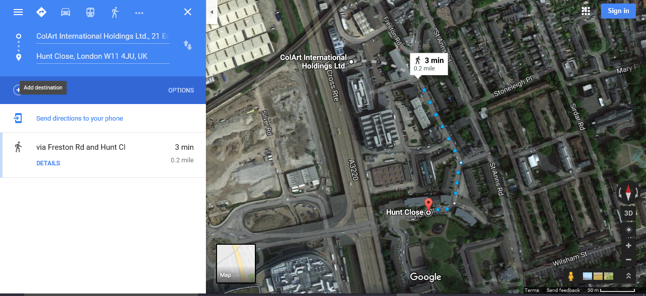

Fire Wardens at Head Office

Main Senior Fire Warden |  | Ajita Chamberlin
Main Deputy Fire Warden |  | Harsa Beagley
Ground Floor
 | Fire Warden | -
3rd Floor
 | Fire Warden | Charlotte Caton
 | Deputy Fire Warden | Catherine Mugnier
4th Floor
 | Fire Warden | Cris Cosgrave
 | Deputy Fire Warden | Fatima Kadic
5th Floor
 | Fire Warden | Josh Hart
 | Deputy Fire Warden | Sophie Schoefer
 | Deputy Fire Warden | Kim Granger
6th Floor
 | Fire Warden | -
 | Deputy Fire Warden | -

