COLART
Contents
Revision History 2
Introduction 3
Responsibilities 3
What is a virus 3
Self-Isolation 3
Managing an employee who is unwell at work 4
General Principles 4
Lifts, tooling, and equipment 4
Cleaning & Disinfection 4
Cleaning after a suspected case 5
Travel & Vehicle Safety 5
Site Access Points 5
Hand Washing & Sanitizing 5
Toilet Facilities 6
Eating Arrangements 6
Common Areas 7
Meetings 7
Personal Protective Equipment 7
Emergencies 7

Revision History
REVISION | CHANGES | NAME | DATE
V2 | Updated to reflect government changes | Laura Tull | 10th August 2020
V3 | Updated to reflect government changes | Joe Hillman | October 2021
V4 | Updated to reflect government changes | Dave Oates | December 27th 2021
V5 | Updated to reflect government changes | Alison Wabe | 21 Jan 2022

Introduction
During the COVID-19 pandemic, whilst carrying out our business we will need to ensure we are protecting ourselves and other contractors’ workforce and minimising the risk of spread of infection.
Our guidance is intended to introduce consistent measures that can be adopted on the site in line with the Government’s recommendations on safe working and social distancing.
These are exceptional circumstances – all industries must comply with the latest Government advice on COVID19.
The health and safety requirements of any activity must not be compromised at this time.
If an activity cannot be undertaken safely due to a lack of suitably qualified personnel being available or an inability to maintain social distancing it shall not take place.

Responsibilities
Management will be responsible for ensuring that all necessary measures are undertaken. Management will be responsible for ensuring best practice is maintained.
All employees are responsible for protecting themselves, their colleagues, their families, and the UK population.

What is a virus
Viruses are the smallest of all the microbes. A virus is made up of a core of genetic material (DNA or RNA). They are surrounded by a protective coat (a capsid) which is made up of protein. Sometimes the capsid is surrounded by a spikey coat (as seen in COVID-19). With these crown-like spikes coronaviruses are efficient at latching onto host cells…and getting inside them.
Viruses depend on a host cell in order to survive and replicate. Viruses survive best on hard surfaces. Non-porous surfaces like stainless steel and plastic slow the drying process and can give the virus added time.
Soap molecules are similar to the ones making up the outer layer of the virus. The virus molecules are strongly attracted to the soap molecules. The soap disrupts the neatly ordered shell around the virus, dissolving it in the running water and killing the virus. Viruses cannot be treated with antibiotics.

Self-Isolation
Workers who have symptoms of COVID-19 however mild, should not come into the office. Symptoms will vary depending on the person and variant of the virus, but common indicator symptoms include:

- a high temperature,
- new and persistent cough
- or have changes to their taste and smell

The new Omicron variant symptoms can be

- runny nose
- headache
- fatigue (either mild or severe)
- sneezing
- sore throat
Please follow the latest government guidance for rules on self isolation and testing: Coronavirus (COVID-19): guidance and support - GOV.UK (www.gov.uk)

Managing an employee who is unwell at work
If a worker develops symptoms while at work, they should:

- Return home immediately
- Avoid touching anything
- Cough or sneeze into a tissue and put it in a bin, or if they do not have tissues, cough, and sneeze into the crook of their elbow.
- Follow the guidance on self-isolation and not return to work until they have been tested and their period of self-isolation has been completed.
- Ensure the areas they have been in and their equipment are cleaned.

General Principles
Going forward, to prevent transmission and ensure we comply with the governments guidelines we will:

- Encourage good hygiene practices.
- Encourage all staff to have the available Covid-19 vaccinations.
- Encourage all staff to carry out a regular Lateral Flow Test (LFT).
- Minimise other staff, visitors, contractors etc. given access to the immediate worksite, or request negative LFT.
- Ensure that work is redesigned to prevent close contact. Where this is not possible implement mitigating control measures such as physical barriers, time limited activities, back-to-back or side to side working methods.
- Ensure that re-usable PPE is thoroughly cleaned and disinfected by users. PPE will not be shared, and it will be stored appropriately.
- Ensure single use PPE is be disposed of so that it cannot be reused. Please do not re use it or share it – this may lead to cross contamination.
- Increase ventilation in enclosed spaces by opening doors (non-fire doors or fire doors with a sound-activated closing system e.g. Dorgard), windows, use of mechanical ventilation (either with fresh air ventilation or recirculation with a HEPA/efficient UV device).
- Ensure adequate ventilation is provided, either by the buildings HVAC system or by opening doors and windows. See Ventilation during the coronavirus (COVID-19) pandemic - HSE

Lifts, tooling, and equipment
Where man riding lifts, hoists, tools, machinery, and equipment must be used:

- Lower lift capacity to reduce congestion and contact at all times
- Regularly clean lift touchpoints, doors, buttons etc.
- Clean and disinfect the inside of vehicle cabs and between use by different operators. Ensure all hand holds / touch points are included.
- Clean/disinfect all tooling and equipment.

Cleaning & Disinfection
Enhanced cleaning procedures will be in place on site and within accommodation units etc. Attention will be paid particularly in communal areas, where tooling is shared and there are frequent touch points:

- Taps and washing facilities
- Toilet flush and seats
- Door handles and push plates
- Handrails on staircases and corridors
- Lift and hoist controls
- Machinery and equipment controls
- Tooling
- Food preparation and eating surfaces
- Telephone equipment, including mobiles. Rubbish collection and storage points will be increased. These will be emptied regularly throughout the day including before leaving.

Cleaning after a suspected case
All surfaces that a symptomatic person has touched and possibly contaminated will be thoroughly cleaned and disinfected.

Travel & Vehicle Safety
To remain as safe as possible when travelling to and from site we will:
- Limit passengers in any vehicle. Seating should be done so to maximise the space between each.
- Make use of cleaning and handwashing facilities on arrival. This should be soap and water wherever possible or hand sanitiser if water is not available
- Discuss overseas travel for employees. Ensure that anyone who has returned isolates, or has appropriate Covid testing, in line with the government guidelines.

Site Access Points
In order to prevent cross contamination and encourage social distancing at access points we will encourage the following, as and when necessary:

- Require all persons to wash or clean their hands with sanitiser before entering or leaving the offices.
- Stop all non-essential visitors.
- Introduce one-way flows to prevent cross over.
- Introduce staggered start and finish times to reduce congestion and contact.
- Increase access points, as necessary.
- Remove or disable entry systems that require skin contact e.g. fingerprint scanners.
- Allow two metres between people waiting to enter site.
- Regularly clean and disinfect common contact surfaces at access and exit points.
- Delivery drivers must still be provided access to wash and cleaning facilities – ensure drivers and instructed to follow these rules.

Hand Washing & Sanitizing
Handwashing is a major control in reducing the spread of virus. Additional hand washing facilities will be provided and suitably stocked. Where this is not possible sanitiser must be used.

We will regularly clean and disinfect the hand washing facilities and check soap and sanitiser levels. Ensuring that we provide suitable and sufficient rubbish bins for hand towels with regular removal and disposal.
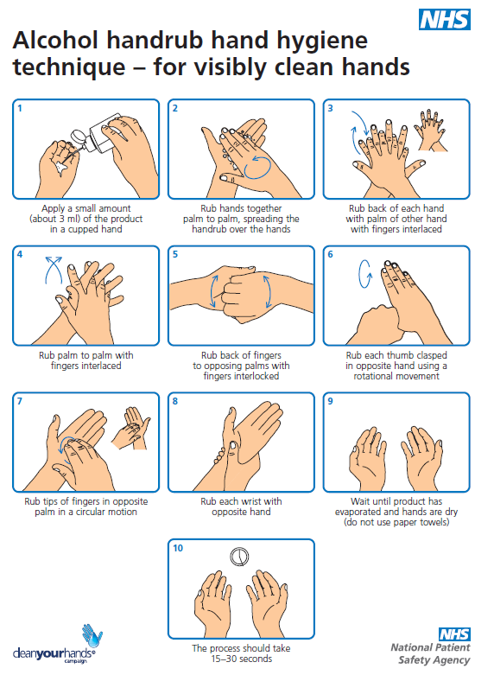

Toilet Facilities
Employees will need to ensure they follow extremely high levels of hygiene washing hands before and after using the facilities.
Toilet facilities (portable or fixed) will be included in the cleaning and disinfection regime particularly door handles, locks, and the toilet flush. Suitable and sufficient rubbish bins will be provided for hand towers with regular disposal.

Eating Arrangements
Whilst there is a requirement for businesses to provide a means of heating food and making hot drinks, they will need to be kept very clean in order to maintain everyone’s health.
- Please wash your hands after removing PPE and before eating, drinking, or using rest facilities. Sanitiser and or washing stations will be available.
- Lunch and breaks will be staggered where necessary in order to maintain social distancing.
- Where canteens are available tables will be cleaned between each use. Supplies will be provided to allow employees to do this as well as cleaning staff.
- Canteens and facilities will be cleaned at the end of each break and shift, including chairs, door handles, vending machines, water dispensers and payment devices.

Common Areas
To maintain social distancing and reduce the spread of infection within common areas (e.g. those areas with a high turnover of people) we will ensure all these areas and regularly and thoroughly cleaned and disinfected and that sufficient rubbish bins are provided in these area.

Meetings
To maintain social distancing and to prevent the spread of infection the way in which site meetings are delivered will be changed. These changes will include:
- Only essential participants asked to attend.
- Limiting number of participants in each meeting room.
- Rooms that are used are well ventilated – windows will be opened to allow fresh air to circulate.

Personal Protective Equipment
Although the wearing of face masks is no longer mandatory, we recommend you use them when walking around the office and in common areas.

Emergencies
Fire

In the event of an emergency such as a fire, social distancing does not need to be adhered to until employees have reached a place of ultimate safety e.g. the muster point.

First aid

First aid provision will still be necessary. In line with the health and safety executives and government guidance, first aiders (FA) are being instructed to follow the recommended controls.

PPE is to be worn, including disposable gloves and apron. A fluid repellent surgical mask and visor or goggles will be worn when attending a casualty where there is a risk from splash, blood, or bodily fluids.

Hand washing and sanitising must take place before and after applying and removing PPE.
First aiders are to try and assist at a safe distance from the casualty if possible and minimise the time they share a breathing zone with them.

If the casualty is capable, they are to be instructed on what to do – however treating the casualty properly should be the first concern.

Where CPR is necessary, rescue breaths should not be used on adults. Chest compressions are to be used in line with the recommendations of resus.org.uk:

- Recognise cardiac arrest by looking for the absence of signs of life and the absence of normal breathing.
- Do not listen or feel for breathing by placing your ear and cheek close to the patient’s mouth. If you are in any doubt about confirming cardiac arrest, the default position is to start chest compressions until help arrives.
- Make sure an ambulance is on its way. If COVID 19 is suspected, tell them when you call 999.
- If there is a perceived risk of infection, rescuers should lightly place a cloth/towel over the victim’s mouth and nose and attempt compression only CPR.
- If a defibrillator is available this should be used until the ambulance (or advanced care team) arrives.
- To perform CPR put hands together in the middle of the chest and push hard and fast.
- After performing compression-only CPR, all rescuers should wash their hands thoroughly with soap and water; alcohol-based hand gel is a convenient alternative. They should also seek advice from the NHS 111 coronavirus advice service or medical adviser.

