Mentor Profile

First name | Cris
Last name | Cosgrave
Job Title | Group Regulatory Affairs Director
Business Area | Sustainability
Location | London, UK
Email address | Cris.cosgrave@colart.com
Phone Number | Click here to enter text.
Languages for Mentoring | English
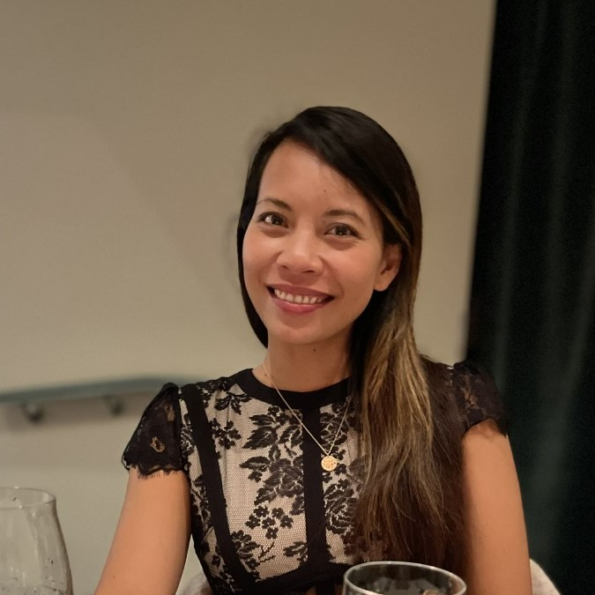

Experience: describe here your professional experience in a few words

I joined Colart eight years ago as part of the Innovation and Development team in London. Since then, I’ve taken on several roles, making me a living example of the company’s lateral movement opportunities. With a background in Chemistry, I have gained experience across multiple industries, including petroleum, food, pharmaceuticals, and decorative paints.
Key skills: write here your key skills and competences with the help of #

#organisation #networkintroduction #technicalknowledge #activelistening #relationshipbuilding #problemsolving #projectmanagement #empathicmanager

On a more personal note…

I was born and raised in the Philippines (native language, Filipino) and moved to London in 2010. I’m also a full-time working mom to my cheeky but lovely six-year-old son, Odran, who started Year 1 this year. I enjoy cooking on weekends for my little family and recently developing my love for reformer Pilates.
Where you can add value:

I'm a good listener and communicator, which allows me to support others in finding their own path. I enjoy problem-solving and helping colleagues gain clarity and confidence in their careers. Whether it's offering advice, sharing potential opportunities, exchanging experiences, or simply being a sounding board for ideas, I’m passionate about helping others grow and succeed.

Personal experience/training underpinning the added value you can bring to the Mentee
e.g. knowledge of company, personal development, self-awareness, confidence building, creativity

I have a strong understanding of the business and its evolution over the years. Having taken on various roles in the past eight years, I’ve gained valuable exposure to different business units and p, enabling me to offer guidance on navigating change, understanding company culture, and identifying growth opportunities. Additionally, I am an alumna of Leaders Plus, a fellowship that supports parents in staying ambitious in their careers while being present for their children

