Useful Mental Health Links

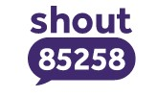 | Shout 85258  Aimed towards: All.  Description: Shout 85258 is a free, confidential, 24/7 text messaging support service for anyone who is struggling to cope.  Text: Shout to 85258 (free, 24/7)  Website: https://giveusashout.org/
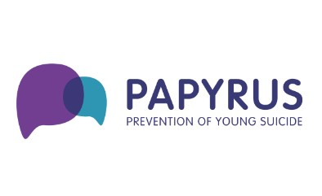 | PAPYRUS  Aimed towards: Under 35s  Description: A charity dedicated to the prevention of suicide and the promotion of positive mental health. Tel: 0800 068 4141 (Free 9am – midnight)  Website: https://www.papyrus-uk.org/
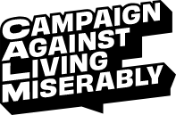 | CALM  Aimed towards: All.  Description: CALM offer confidential, anonymous, and free support, information and signposting through the helpline or webchat. People can talk through a wide variety of issues including abuse, addictions, anger, depression, bullying, eating disorders, sexuality, work issues, racism, bereavement, suicide, divorce and more. The website holds information on a range of issues and lists national organisations offering support with some of these issues.  Tel: 0800 58 58 58 (free, 5pm – midnight)  Website: https://www.thecalmzone.net/
 | Samaritans  Aimed towards: All.  Description: Samaritans is a registered charity aimed at providing emotional support to anyone in emotional distress, struggling to cope, or at risk of suicide throughout Great Britain and Ireland.  Tel: Call 116123 (free, 24/7)  Website: https://www.samaritans.org
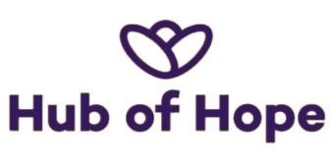 | The Hub of Hope  Aimed towards: All.  Description: The Hub of Hope is a first of its kind, national mental health database which brings together organisations and charities, large and small, from across the country who offer mental health advice and support, together in one place.  Website: https://hubofhope.co.uk/
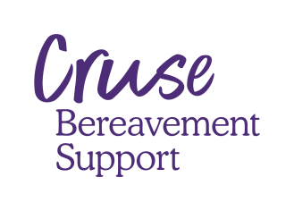 | Cruse  Aimed towards: Anyone bereaved.  Description: Cruse Bereavement Care is the leading national charity for bereaved people in England, Wales, and Northern Ireland.  Website: https://www.cruse.org.uk/
 | Andy’s Man Club  Aimed towards: Males.  Description: We are open for face-to-face meetings every Monday (except bank holidays) at 7pm and currently have 35 groups across England and Scotland. We also have a national online group every Monday at 7pm for those outside of our catchment areas. For information about how to book on to one of our sessions, either in person or online, please send an email to info@andysmanclub.co.uk and our team will be able to assist.  Website: https://andysmanclub.co.uk/
 | Student Minds  Aimed towards: Students.  Description: If you are a student struggling with mental wellbeing or looking to support someone you know, Student Minds are a charity focused on preventing mental health issues by focusing on educating and providing students with a wellbeing toolkit. Student Minds can help support you by offering student-led peer support programmes and signposting you to resources that can support your needs.  Website: https://www.studentminds.org.uk/
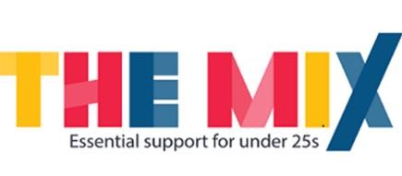 | The Mix  Aimed towards: Under 25s  Description: The Mix is the UK's free, confidential helpline service for young people under 25 who need help, but don't know where to turn. Open 365 days a year, for absolutely anything you are going through.  Tel: 0808 808 4994 (open 3pm - 12am everyday)  Website: https://www.themix.org.uk/
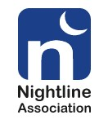 | Nightline  Aimed towards: University Students  Description: Emotional support for students in distress. Nightlines are confidential, anonymous, non-judgemental, non-directive and non-advisory support services run by students for students.  Website: https://nightline.ac.uk/want-to-talk/
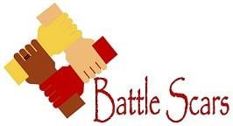 | Service: Battle Scars  Aimed towards: Supporting anyone affected by self-harm  Description: Battle Scars do not offer crisis support. If you've been affected by self-harm, you are not alone. Battle Scars is a charity dedicated to decreasing the stigma, raising awareness and supporting anyone affected by self-harm. They offer a variety of resources to help understand and manage self-harm and encourage people who struggle with self-harm to reach out and build a support network. They offer services such as Peer support for families of people who self-harm, Adult Peer Groups and an Under 18's Service which include workshops on managing self-harm for young people and how to disclose or talk to someone about it.  Website: https://www.battle-scars-self-harm.org.uk/
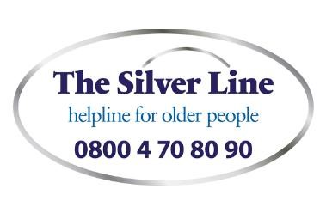 | The Silver Line  Aimed towards: The older community.  Description: The Silver Line is the only free confidential helpline providing information, friendship and advice to older people, open 24 hours a day, every day of the year.  Tel: 0800 4 70 80 90 (free, 24/7)  Website: https://www.thesilverline.org.uk/
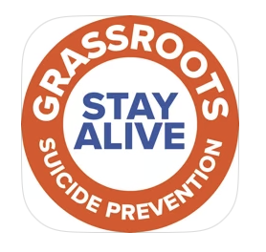 | Stay Alive App  Aimed towards: All.  Description: The Stay Alive app is a pocket suicide prevention resource for the UK, packed full of useful information to help you stay safe. You can use it if you are having thoughts of suicide or if you are concerned about someone else who may be considering suicide.  Website: https://prevent-suicide.org.uk/find-help-now/stay-alive-app/
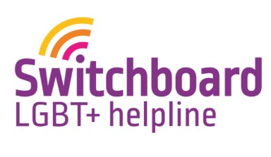 | Switchboard LGBT+ Helpline  Aimed towards: LGBTQ+ community.  Description: You can talk about anything with the Switchboard volunteers, who all self-define as LGBT+.  Nothing is off limits, and the volunteers understand how anxious you might feel before you pick up the phone. Calls are confidential and they only finish when you’re ready.  Tel: 0800 0119 100 (lines open every day 10am-10pm)  Website: https://switchboard.lgbt/
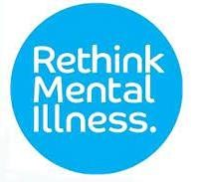 | Rethink  Aimed towards: All  Description: Rethink provides expert, accredited advice and information to everyone effected by mental health problems. They have mental health services and support groups across England, find your nearest service via the website. Rethink Advice and Information Service: offers practical help on issues such as the Mental Health Act, community care, welfare benefits, debt, criminal justice and carers rights. They also offer general help on living with mental illness, medication, care and treatment.  Tel: 0808 801 0525 (weekdays 1pm to 4pm)  Website: https://www.rethink.org/
Black Minds Matter UK
Aimed towards: Black individuals.

Description: Black Minds Matter UK is a fully registered charity operating in the UK; connecting Black individuals and families with free mental health services- by professional Black therapists to support their mental health. Our vision is to make mental health topics more relevant and accessible for all Black people in the U.K., removing the stigma and remodelling the services to be relevant for the Black community.
Website: https://www.blackmindsmatteruk.com/

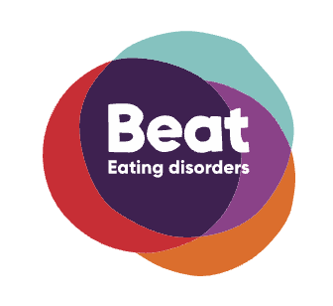 | Beat  Aimed towards: Anyone with any experience of eating disorders.  Description: Beat, an eating disorders charity, provides a helpline offering support and information about eating disorders.  Tel: 0808 801 0677.  Website: https://www.beateatingdisorders.org.uk/
 | The Black, African and Asian Therapy Network  Aimed towards: people who identify as Black, African, South Asian and Caribbean.  Description: Address the inequality of access to appropriate psychological services for Black, African, South Asian and Caribbean people, which is a well-recognised reality¹.  Website: https://www.baatn.org.uk/
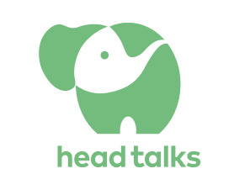 | Head Talks  Aimed towards: All.  Description: Head Talks aims to inform, inspire, and engage those interested in mental health and wellbeing.  Find people speaking from the heart and from their own experience, as well as a wide range of experts and healers sharing their tips and insights to help us work towards better mental health and wellbeing.  Website: https://www.headtalks.com

Useful videos about mental health

Brene Brown – Empathy v Sympathy | https://www.youtube.com/watch?v=KZBTYViDPlQ
It’s not about the nail! | https://www.youtube.com/watch?v=-4EDhdAHrOg
Helpful and unhelpful listening skills | https://www.youtube.com/watch?v=3ygJCgTYtbo
Suzy’s journey to work | https://www.youtube.com/watch?v=SQnZiCc_uN0
Things Not To Say To Someone With Schizophrenia | https://www.youtube.com/watch?v=IIFPUpqS5dc

Mental health campaigns

Time to talk day | Feb
Children’s Mental Health Week | Feb
Eating disorder week | Feb
World sleep day | Mar
International Day of Happiness | Mar
University Mental Health Day | Mar
Stress awareness month | Apr
National conversation week | Apr
Mental health awareness week | May
Men's Health Week | Jun
24/7 Samaritans - The Big Listen | Jul
World Suicide Prevention Day | Sep
National Work Life Week | Oct
World Mental Health Day | Oct
National Stress Awareness Day | Nov
International Survivors of Suicide Loss Day | Nov

